Kapture - MDM (Master Data Maintenance) Tools, Import and Export Unit Test Cases

Contents
1. User System Access 3
2. RUM VIN 4
3. CD ROM Creation 5
4. ESI Labels Update Schedule 18
5. MME Translation Update 19
6. RMI Export Tool 25
7. Service Information Data Import 34
8. MNAO Data Export Tool 39
9. MGSS Bulk Data Extract & Transfer Tool 48
10. MGSS Bulk Data - Run On Demand Job 65
11. MGSS Bulk Data - Extract Job 66
12. MGSS Bulk Data - Transfer Job 72
13. MGSS Bulk Data - Rerun 79

Kapture - MDM (Master Data Maintenance) - Tools, Import and Export
Unit Test Cases
Application URL: https://na.dev.mgss.oc.mazda.com/mdmgt
Application: mdmgt.war (/mdmgt) | Version: v3 | Date: 28-Oct-2026
- Unit Test Case Summary:
# | Test Cases Processes | No. of Test Cases | No. of Success | No. of Failure | Status
1 | User System Access | 1 | 1 | 0 | Pass
2 | RUM VIN | 1 | 1 | 0 | Pass
3 | CD ROM Creation | 5 | 5 | 0 | Pass
4 | ESI Labels Update Schedule | 1 | 1 | 0 | Pass
5 | MME Translation Update | 3 | 3 | 0 | Pass
6 | RMI Export Tool | 4 | 4 | 0 | Pass
7 | Service Information Data Import | 3 | 3 | 0 | Pass
8 | MNAO Data Export Tool | 4 | 4 | 0 | Pass
9 | MGSS Bulk Data Extract & Transfer Tool | 10 | 10 | 0 | Pass
10 | MGSS Bulk Data - Run On Demand Job | 1 | 1 | 0 | Pass
11 | MGSS Bulk Data - Extract Job | 7 | 7 | 0 | Pass
12 | MGSS Bulk Data - Transfer Job | 3 | 3 | 0 | Pass
13 | MGSS Bulk Data - Rerun | 1 | 1 | 0 | Pass
 | Total | 44 | 44 | 0 | Pass

User System Access
- User should be able to open MDM and view the Tools, Import and Export tab on My Page.
Steps:
1. Log in to MGSS with a valid user.
2. Open the URL: https://na.dev.mgss.oc.mazda.com/mdmgt
3. Click the Tools, Import and Export tab.
Expected Result: The tab lists the tiles RUM VIN, CD ROM Creation, ESI Labels Update Schedule, MME Translation Update, RMI Export Tool, Service Information Data Import, MNAO Data Export Tool and MGSS Bulk Data Extract & Transfer Tool.
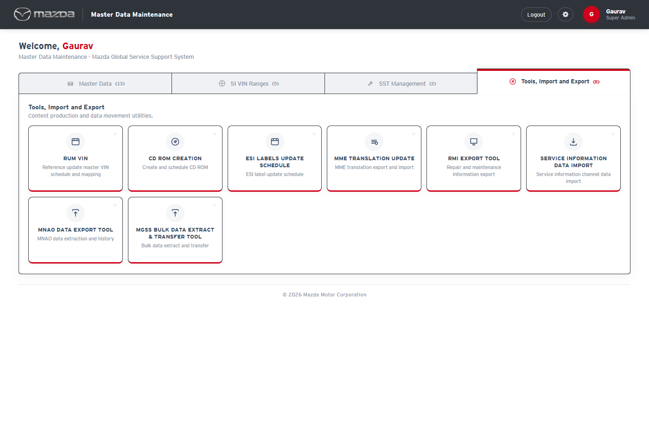
My Page - Tools, Import and Export tab
Status: Pass
Remarks:

RUM VIN
- User should be able to view the RUM VIN schedule history and the RUM VIN mappings.
Steps:
1. From My Page > Tools, Import and Export, click RUM VIN.
2. Click RUM VIN Mapping in the top menu.
Expected Result:
- RUM VIN Schedule lists the monthly schedules with schedule / finish time, line counts, file name, schedule status, job status and remarks.
- RUM VIN Mapping Details lists the VIN at RUSSIA to VIN at MAZDA mappings with creation and last modified time.
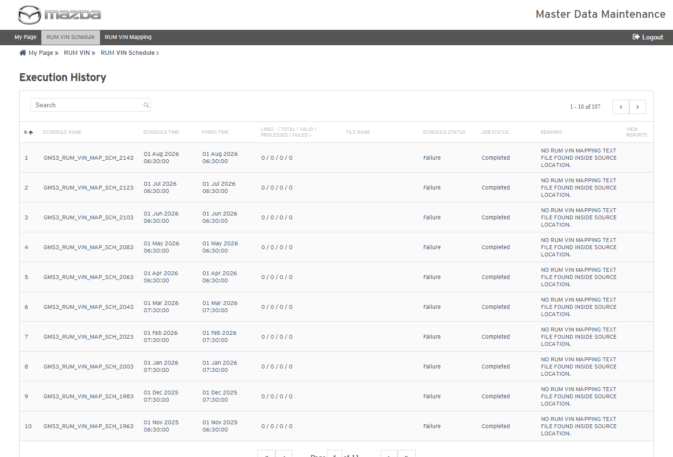
RUM VIN Schedule - Execution History
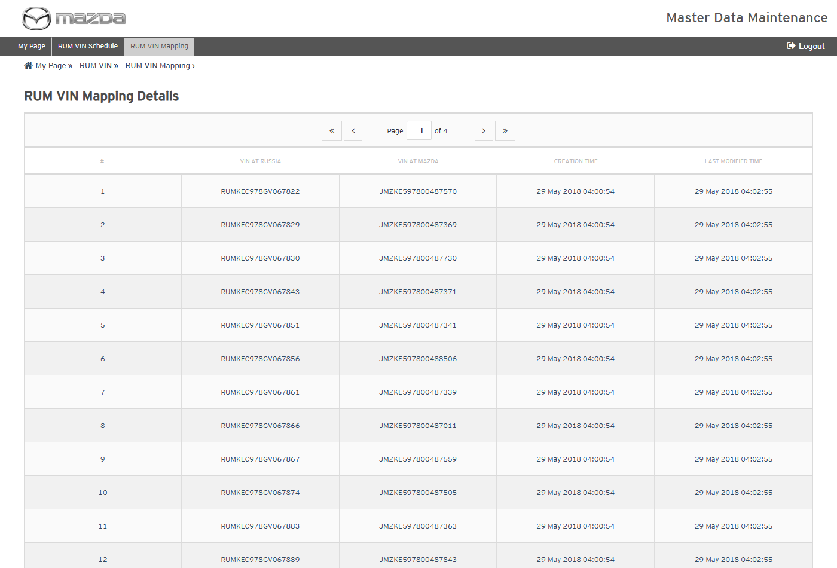
RUM VIN Mapping Details
Status: Pass
Remarks:

CD ROM Creation
CD ROM Creation builds an offline CD of the Service Manual / Wiring Diagram content of a VIN. The cases below are executed with Country Japan, Language Japanese, Model プレマシー(CR) and VIN - / CR3W / 100001.
- System should not search without the mandatory fields.
Steps:
1. From My Page > Tools, Import and Export, click CD ROM Creation.
2. Click Go.
Expected Result: "Please fill all the fields marked as mandatory (*)." is shown.
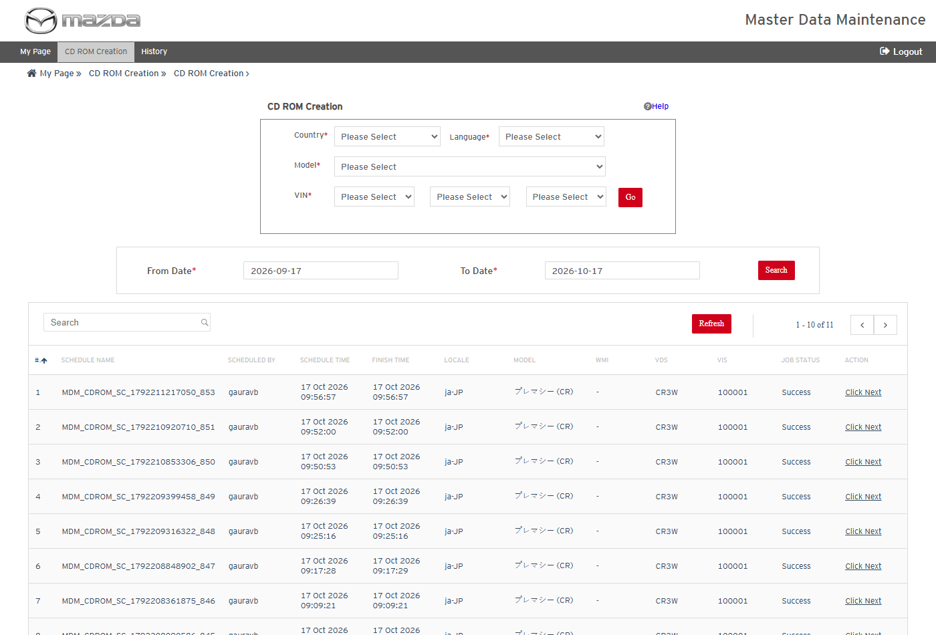
CD ROM Creation
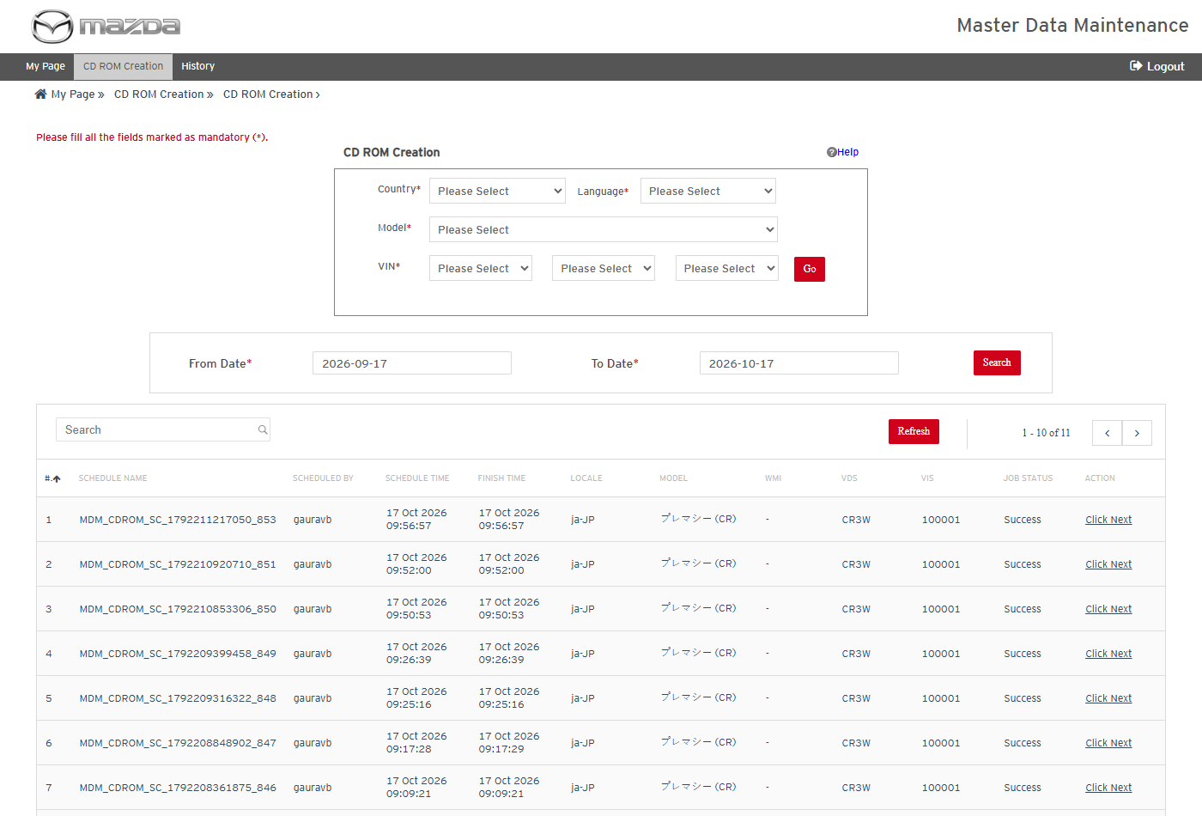
Mandatory field message
Status: Pass
Remarks:

- User should be able to search the manuals available for a VIN.
Steps:
1. Select Country Japan, Language Japanese, Model プレマシー(CR) and VIN - / CR3W / 100001.
2. Click Go.
Expected Result:
- A search schedule (MDM_CDROM_SC_...) is created and completes with job status Success.
- Click Next opens "Select a necessary item" with the Service Contents, Engine Workshop Manual and Transmission Workshop Manual available for the VIN.
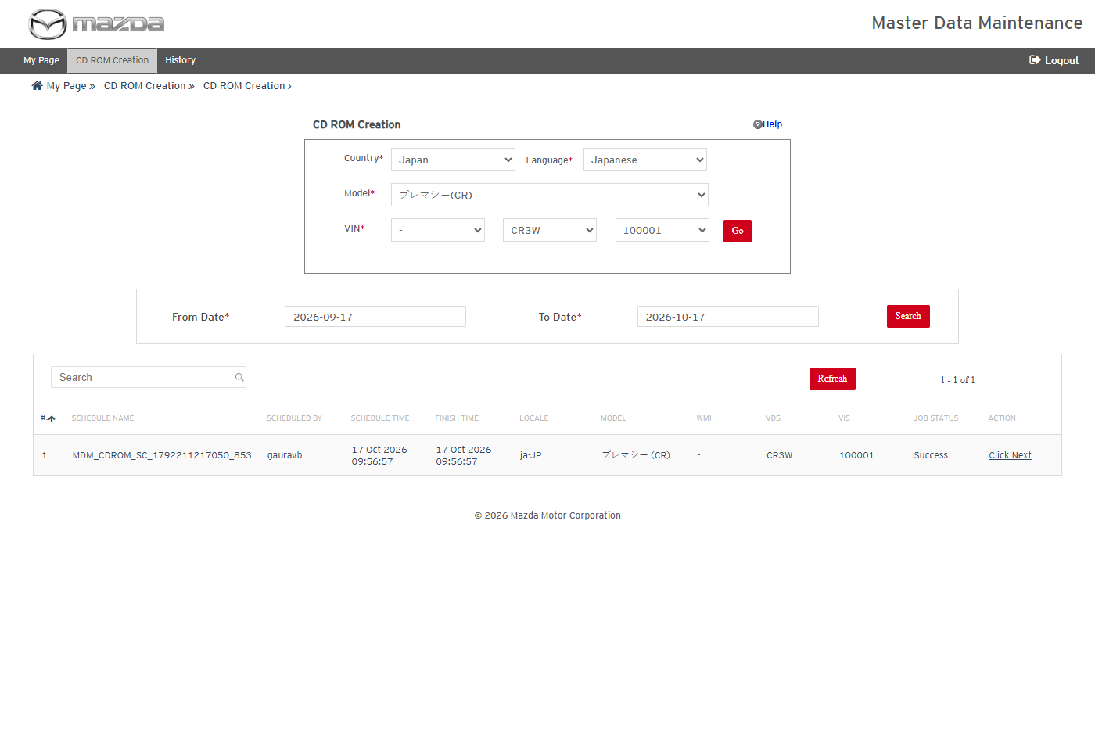
VIN selected
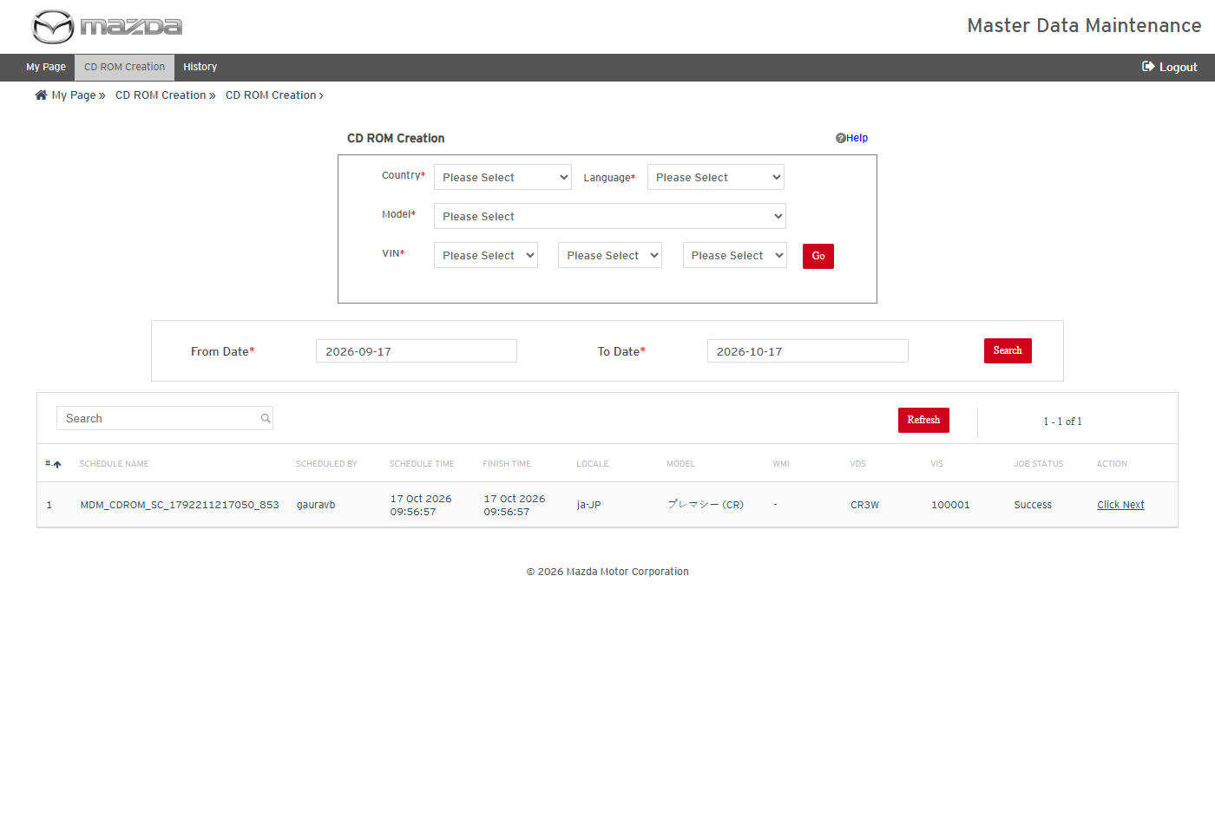
Search schedule completed
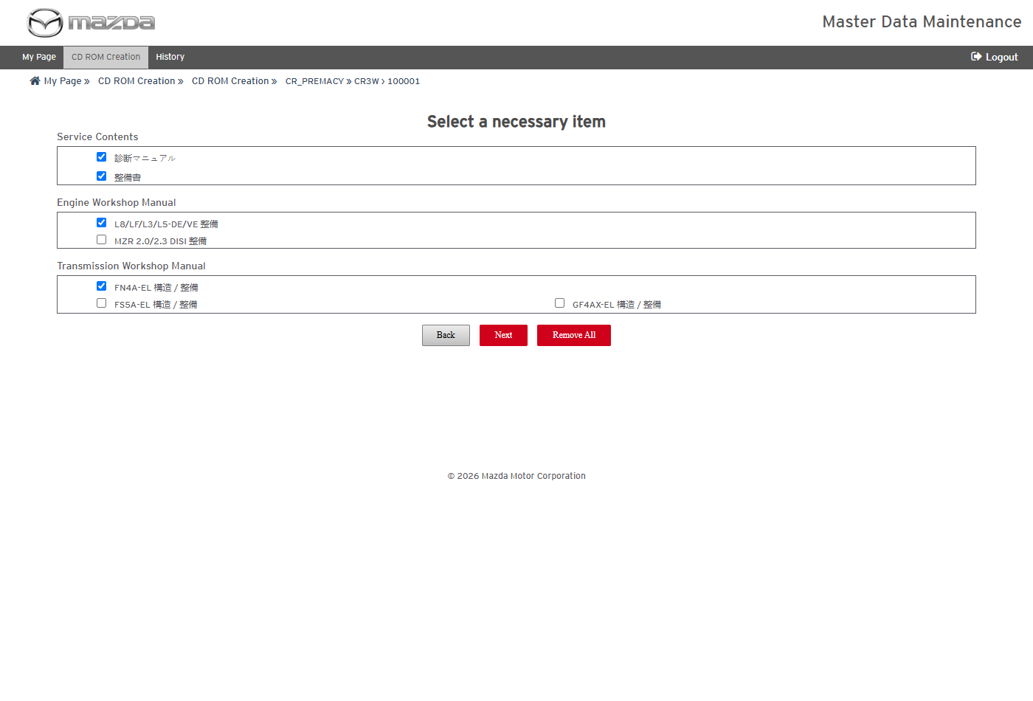
Select a necessary item
Status: Pass
Remarks:

- User should be able to select a manual and schedule the CD creation.
Steps:
1. Select only 整備書 (Workshop Manual) under Service Contents and click Next.
2. Check Total Docs for Processing and click Submit.
3. Click Schedule on the confirmation.
Expected Result:
- The selection page lists 整備書 with Total Docs for Processing 1.
- The CD creation is scheduled (MDM_CDROM_..._856) and processed in the background.
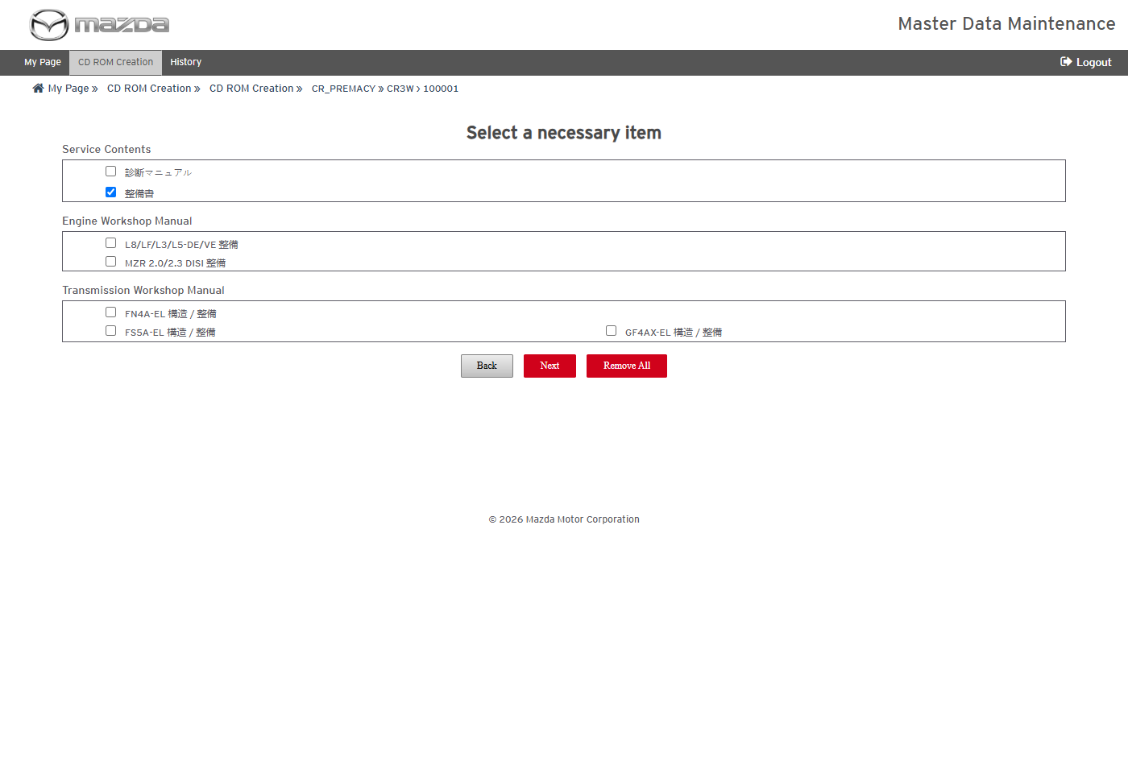
Manual selected
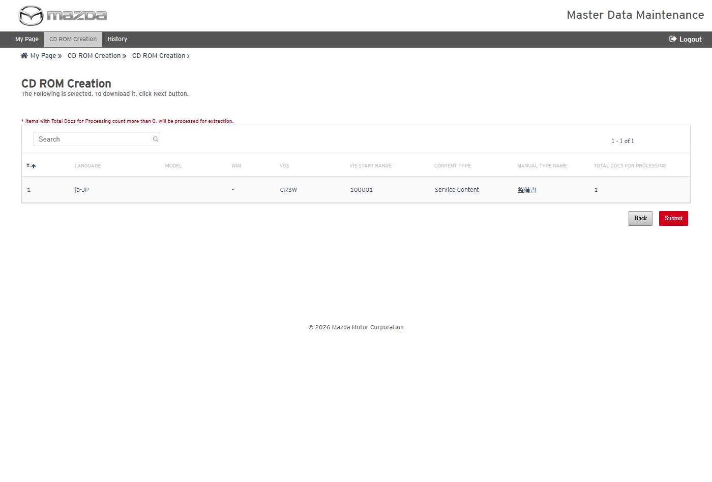
Selection summary
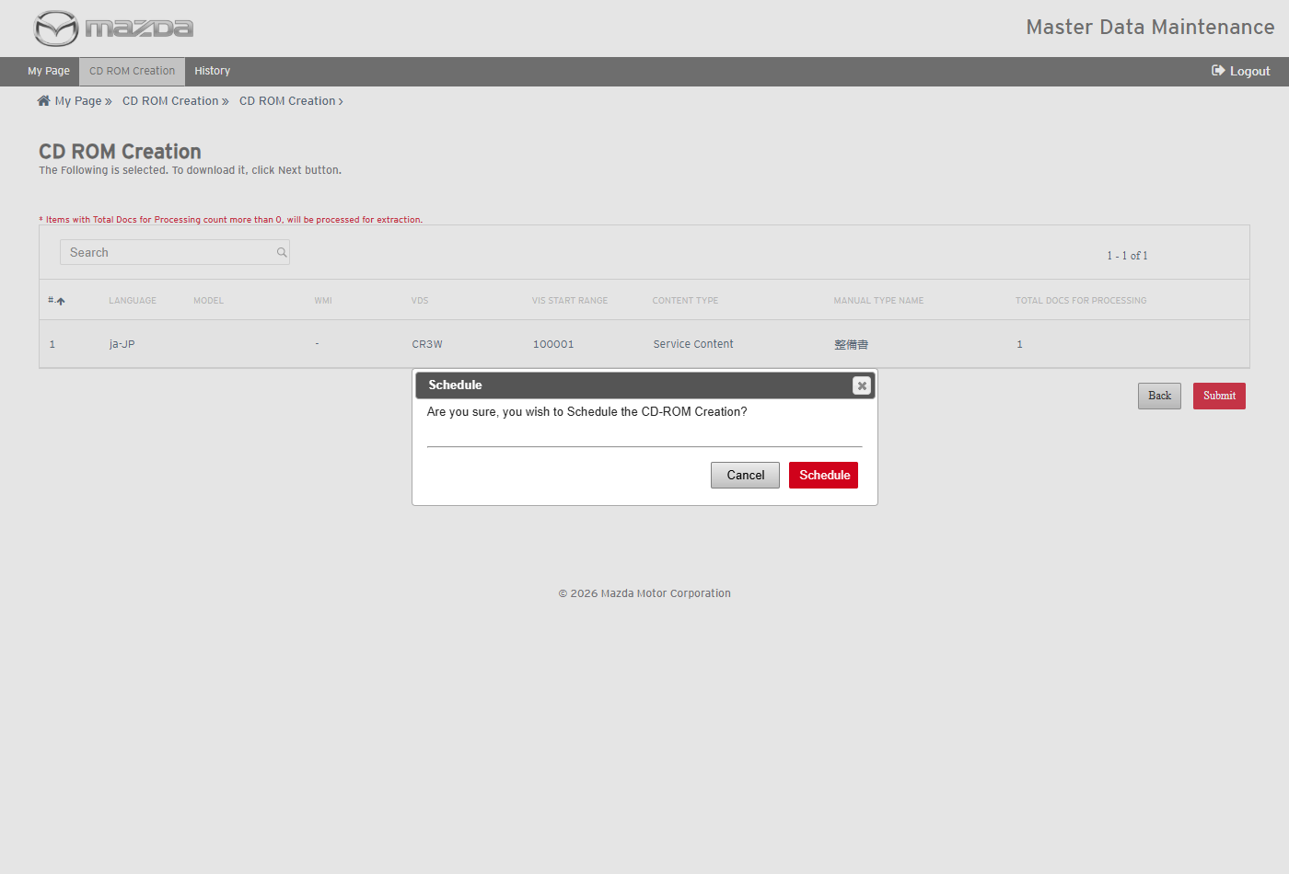
Schedule confirmation
Status: Pass
Remarks:

- User should be able to view the CD creation history and reports.
Steps:
1. Click History in the top menu.
2. Download the reports of the schedule.
Expected Result:
- The schedule shows Documents 1 / 1 / 0, OKAssets 2 / 2 / 0, Inner Links 0 / 0 / 0, Content Status COMPLETED and Job Status Success, with Download Contents / Reports and View CD ROM.
- The Transaction Report lists SM1558284 with Processing Status Success; the OKAsset Report lists both images copied.
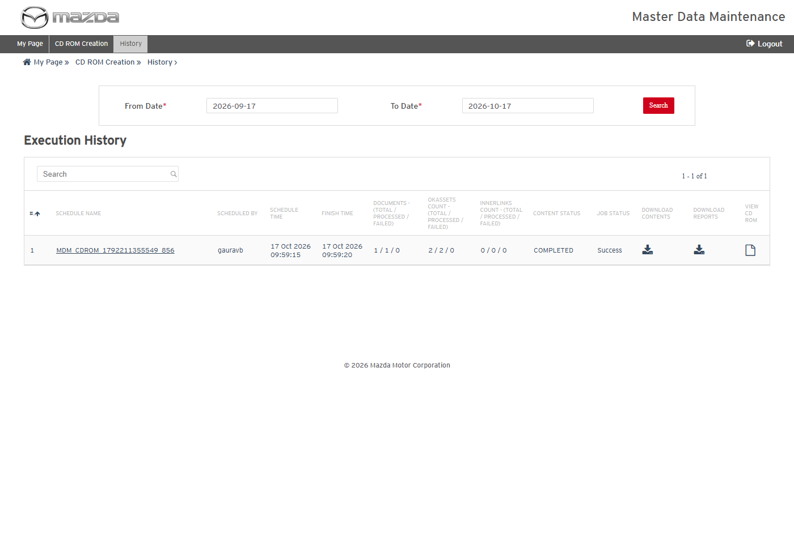
CD ROM Creation History
Transaction Report
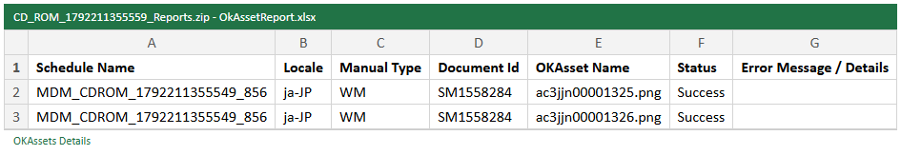
OKAsset Report
Status: Pass
Remarks:

- User should be able to view the created CD ROM in the browser.
Steps:
1. In History, click View CD ROM of the schedule.
2. Open the サービス資料 tab, expand the tree and open the document.
3. Enter クラッチ in キーワード検索 and click 検索.
Expected Result:
- The CD opens with the model / VIN label (プレマシー(CR) CR3W 100001).
- The tree lists 整備書 > B/P(黒桃色線) > クラッチ [C66M-R, C66MX-R]; the document opens with its text and images.
- The keyword search returns the document (合計 : 1).
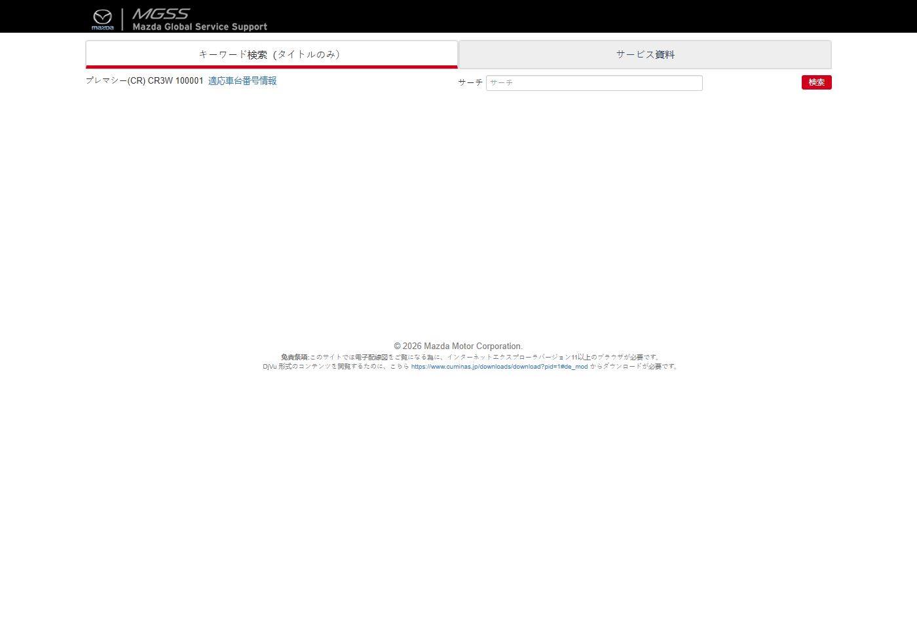
CD ROM - home
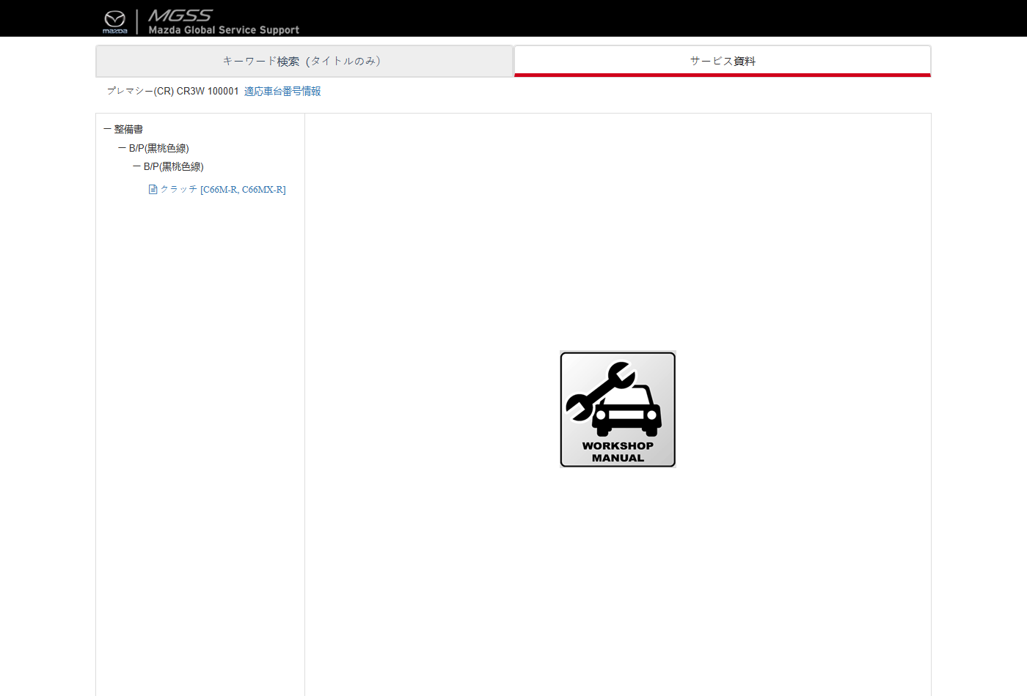
CD ROM - service materials tree
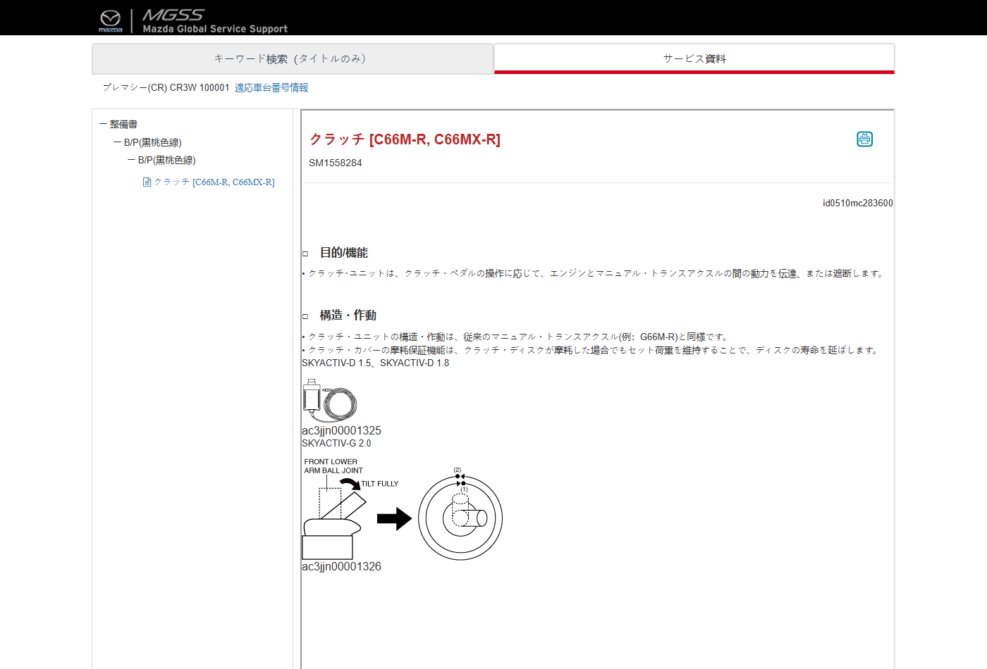
CD ROM - document
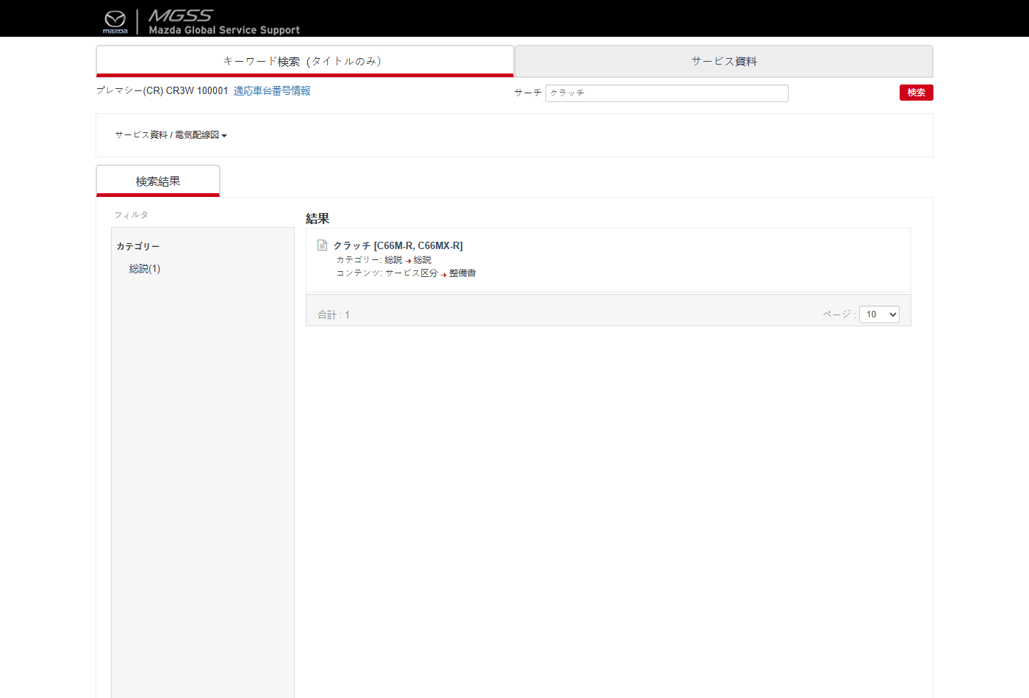
CD ROM - keyword search
Status: Pass
Remarks:

ESI Labels Update Schedule
- User should be able to view the ESI Labels Update schedule history.
Steps:
1. From My Page > Tools, Import and Export, click ESI Labels Update Schedule.
Expected Result: Execution History lists each schedule with schedule / finish time, document counts (total / processed / failed), schedule and job status, remarks and a View Reports download.
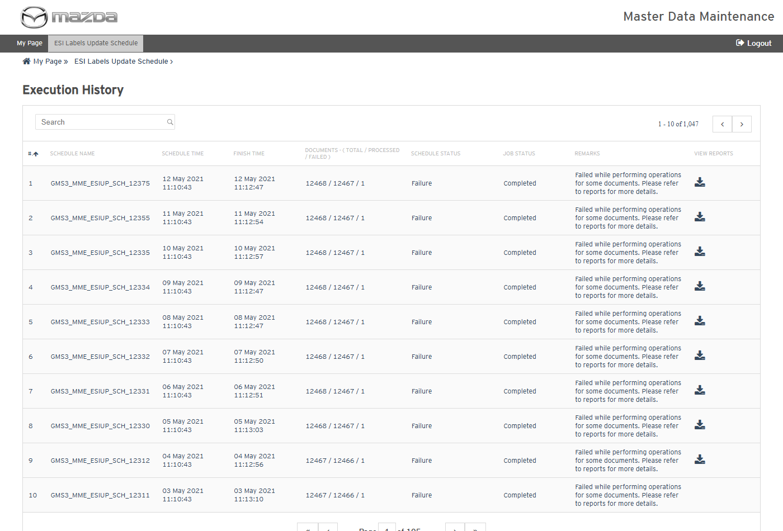
ESI Labels Update Schedule - Execution History
Status: Pass
Remarks:

MME Translation Update
The cases below are executed with Country United States and Language English Us for the Export operation (Import updates the documents in the same manner from the exported files).
- System should not validate without document ids.
Steps:
1. From My Page > Tools, Import and Export, click MME Translation Update.
2. Select the Country and Language and click Validate without document ids.
Expected Result: "Document Id is required. Please enter document id either using Input field or upload a valid excel." is shown.
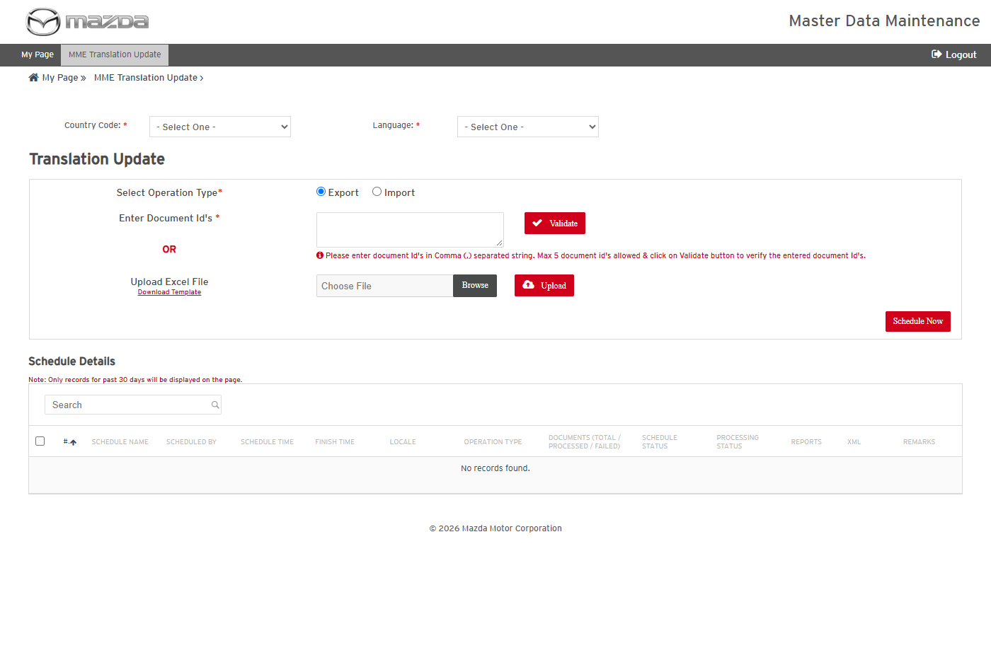
MME Translation Update
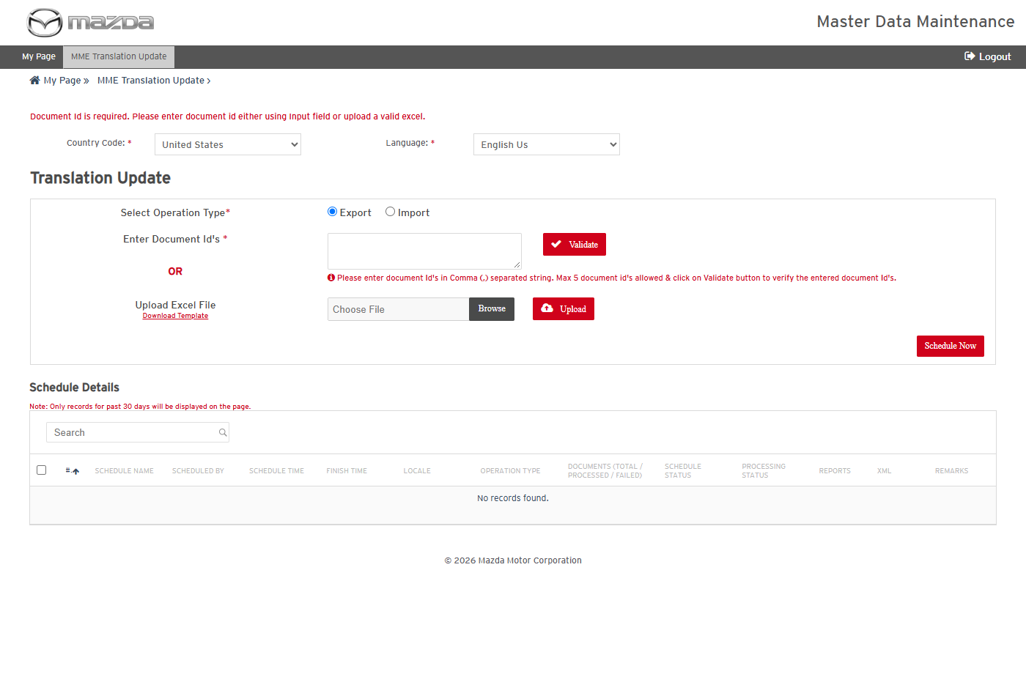
Validation message
Status: Pass
Remarks:

- User should be able to validate document ids and schedule a translation export.
Steps:
1. Select Operation Type Export and enter SI1123,SI1131.
2. Click Validate.
3. Click Schedule Now.
Expected Result:
- Documents to Export shows Total 2 / Success 2 / Failure 0.
- "MGSS_TU_402 scheduled successfully." is shown and the schedule completes with 2 / 2 / 0, Schedule Status Success, Processing Status Completed.
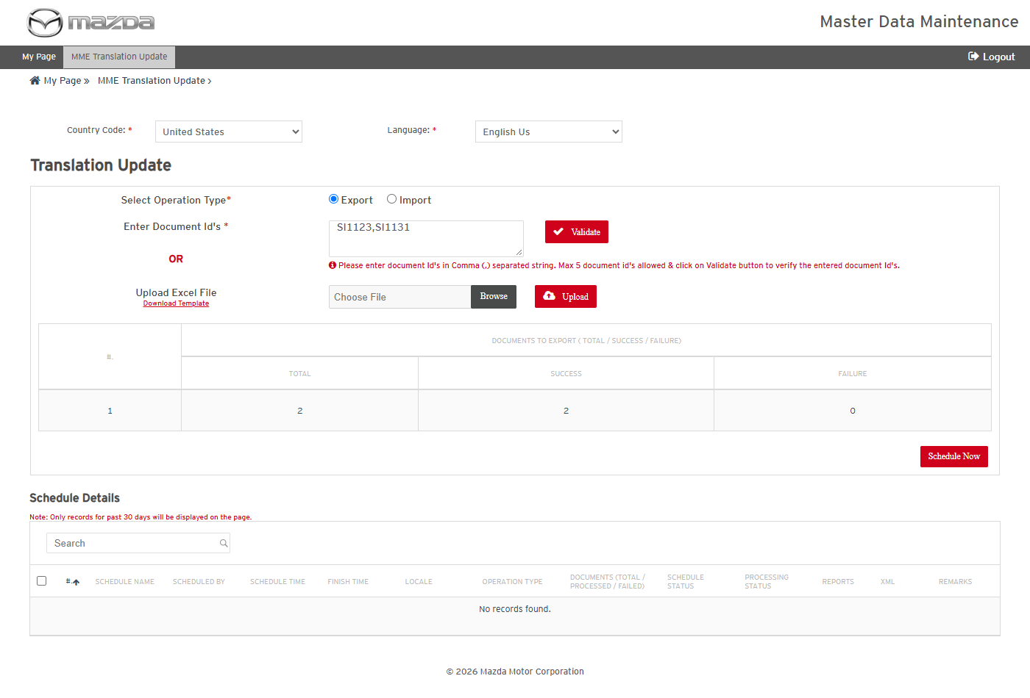
Document ids validated
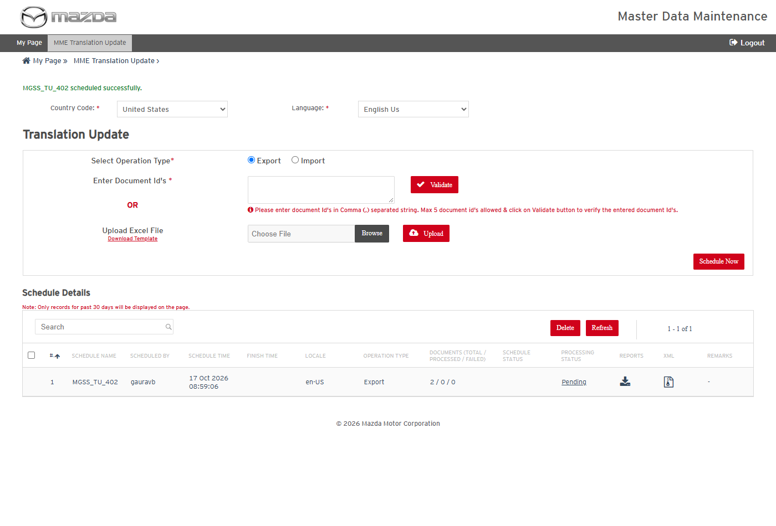
Export scheduled
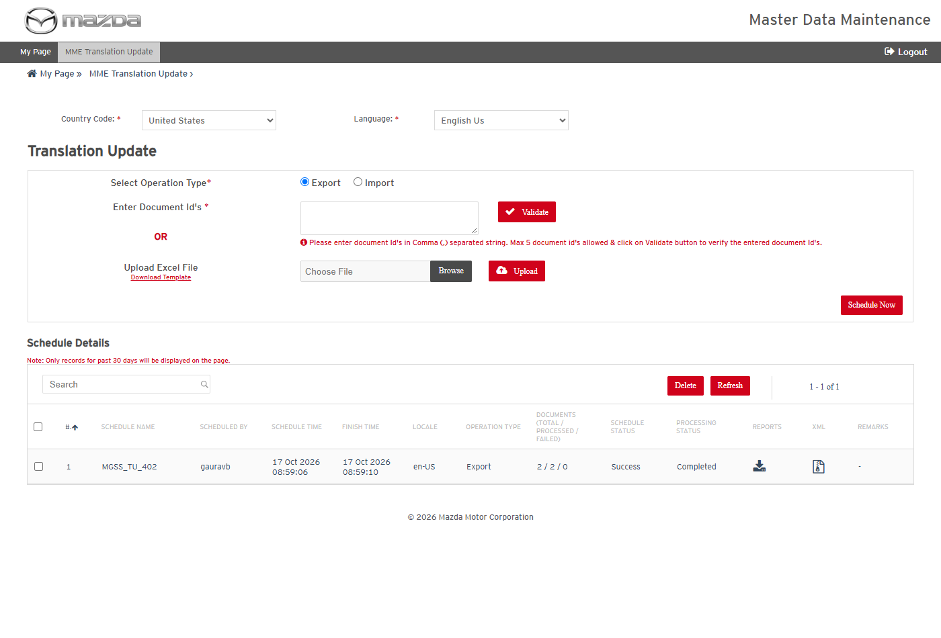
Export completed
Status: Pass
Remarks:

- User should be able to download the translation export report and XML.
Steps:
1. Click the Reports and XML download icons of MGSS_TU_402.
2. Open the files.
Expected Result:
- The transaction report lists SI1123 and SI1131 (en_US, Export) with Processing Status Success.
- The XML zip holds one XML per document with the translatable fields (title, history, summary, description, repair procedure and others).
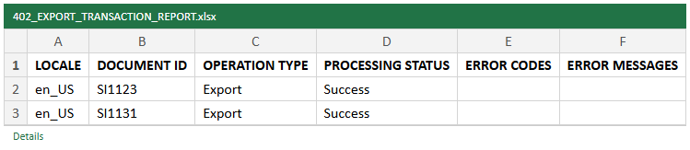
Export transaction report
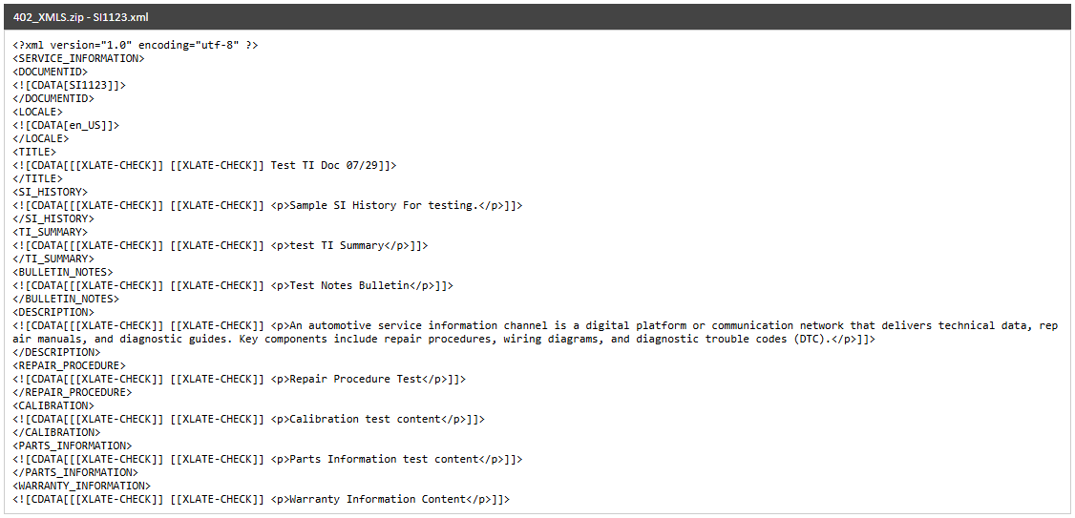
Exported XML - SI1123
Status: Pass
Remarks:

RMI Export Tool
The cases below are executed with Country United Kingdom, Language English (en-UK) and Model BT-50_UP.
- System should not list items without the mandatory fields.
Steps:
1. From My Page > Tools, Import and Export, click RMI Export Tool.
2. Click Go.
Expected Result: "Please fill all the fields marked as mandatory (*)." is shown.
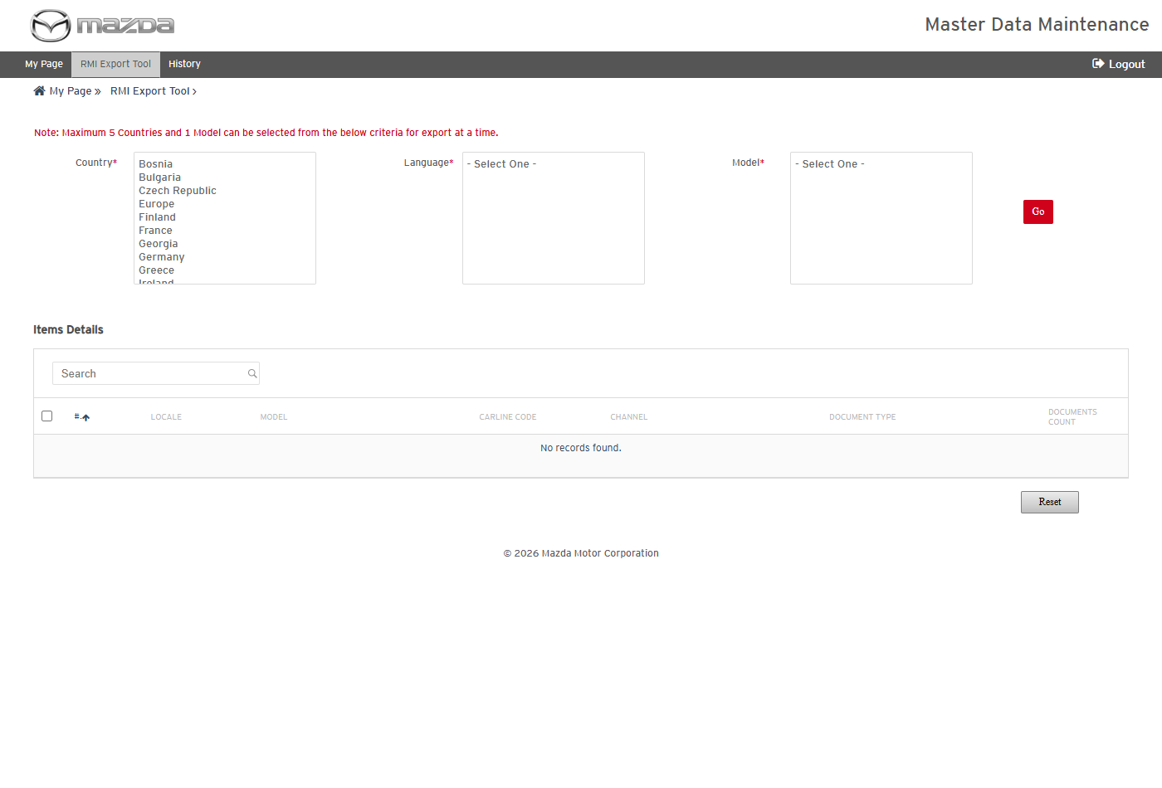
RMI Export Tool
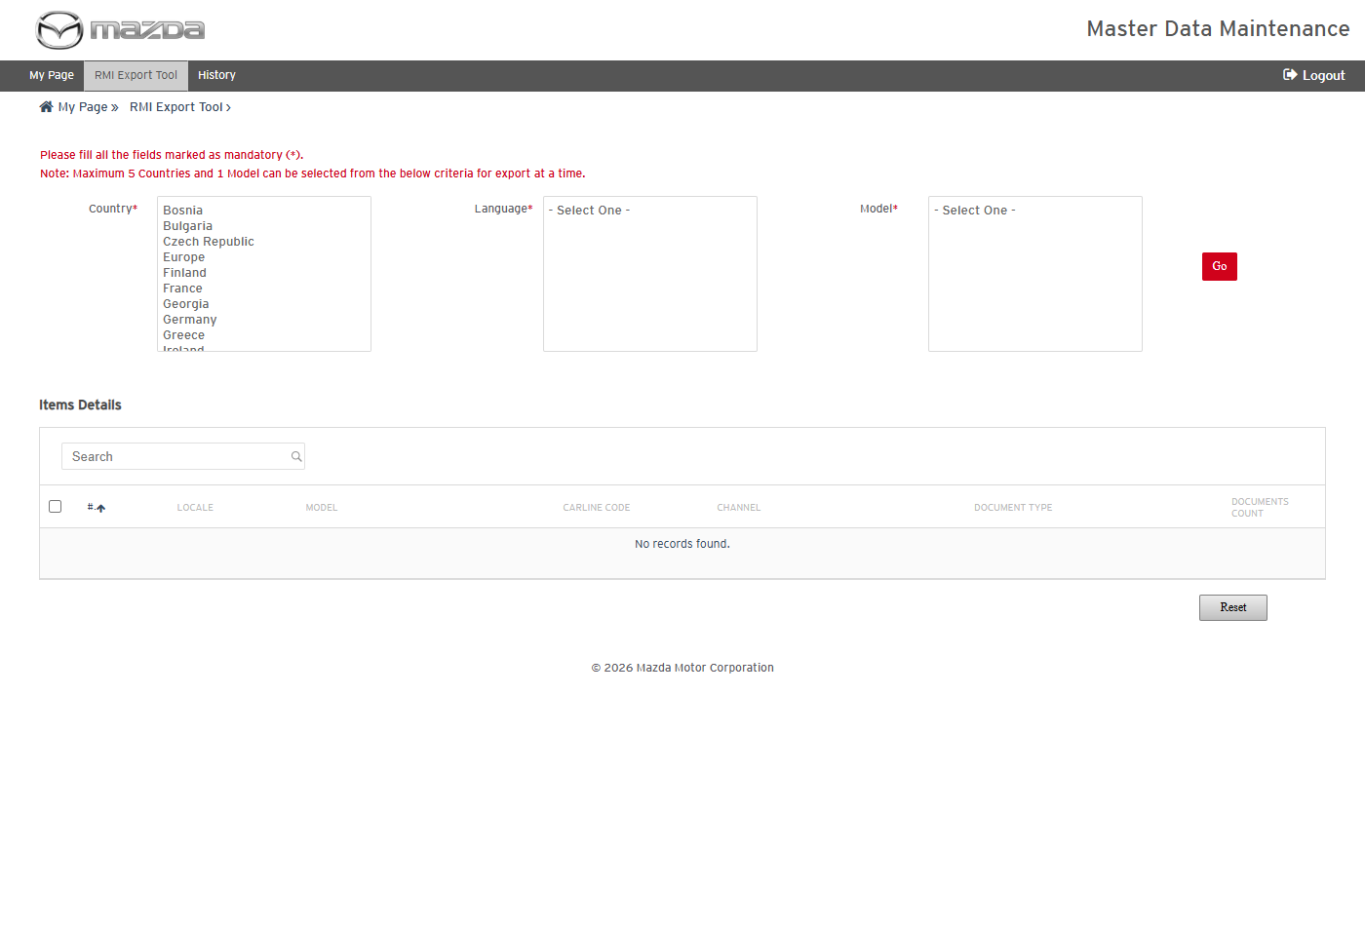
Mandatory field message
Status: Pass
Remarks:

- User should be able to list the items of a model and schedule an RMI export.
Steps:
1. Select Country United Kingdom, Language English (en-UK) and Model BT-50_UP; click Go.
2. Select the SERVICE_INFORMATION / TECHNICAL_INFORMATION item and click Schedule.
Expected Result:
- Items Details lists the channel / document type items of the model with their document counts.
- "Schedule MGSS_RMI_EXPORT_303 scheduled successfully." is shown.
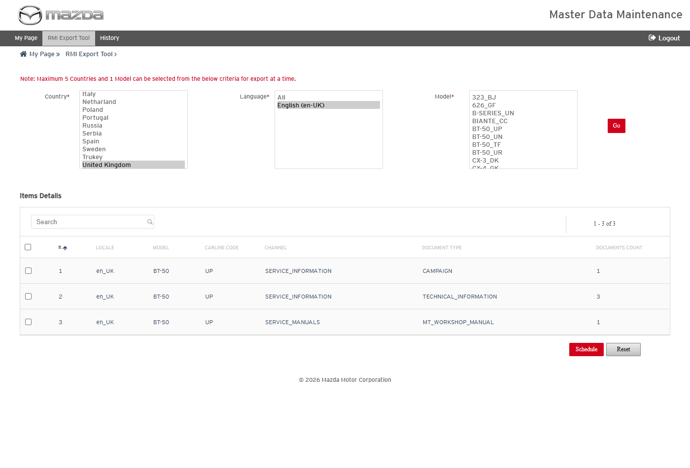
Items of BT-50_UP
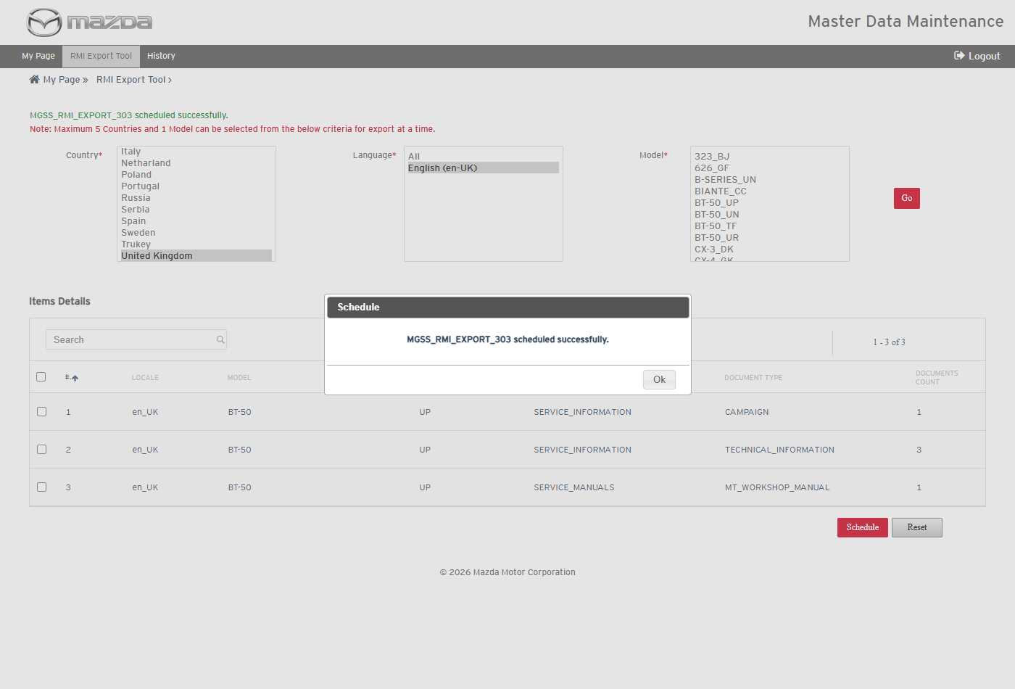
Export scheduled
Status: Pass
Remarks:

- User should be able to view the RMI export history, item details and report summary.
Steps:
1. Click History in the top menu.
2. Click the schedule name, then the Job Summary icon.
Expected Result:
- MGSS_RMI_EXPORT_303 shows Documents 3 / 3 / 0, Content Export Progress Completed and Job Status Success.
- Item Details and Reports Summary Details show the item and the Document Extraction Report with 3 success transactions.
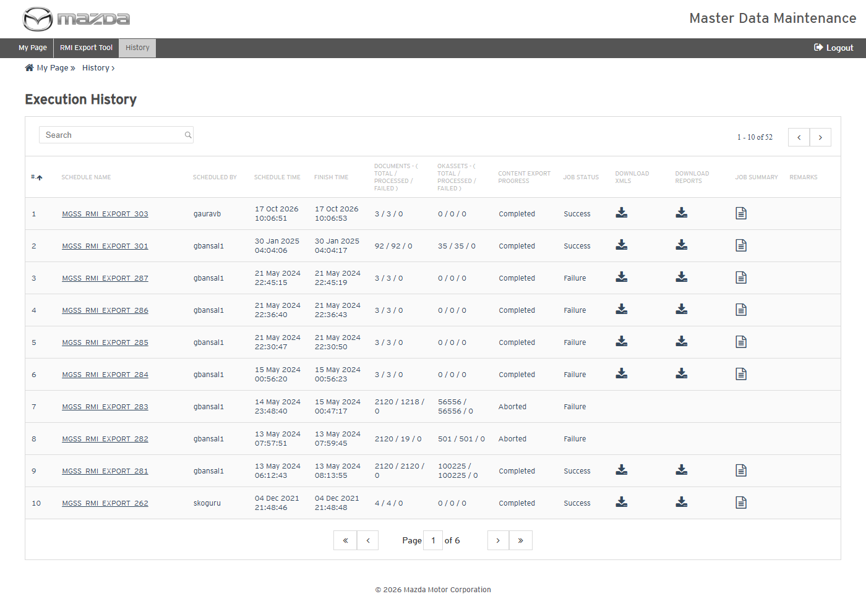
RMI Export History
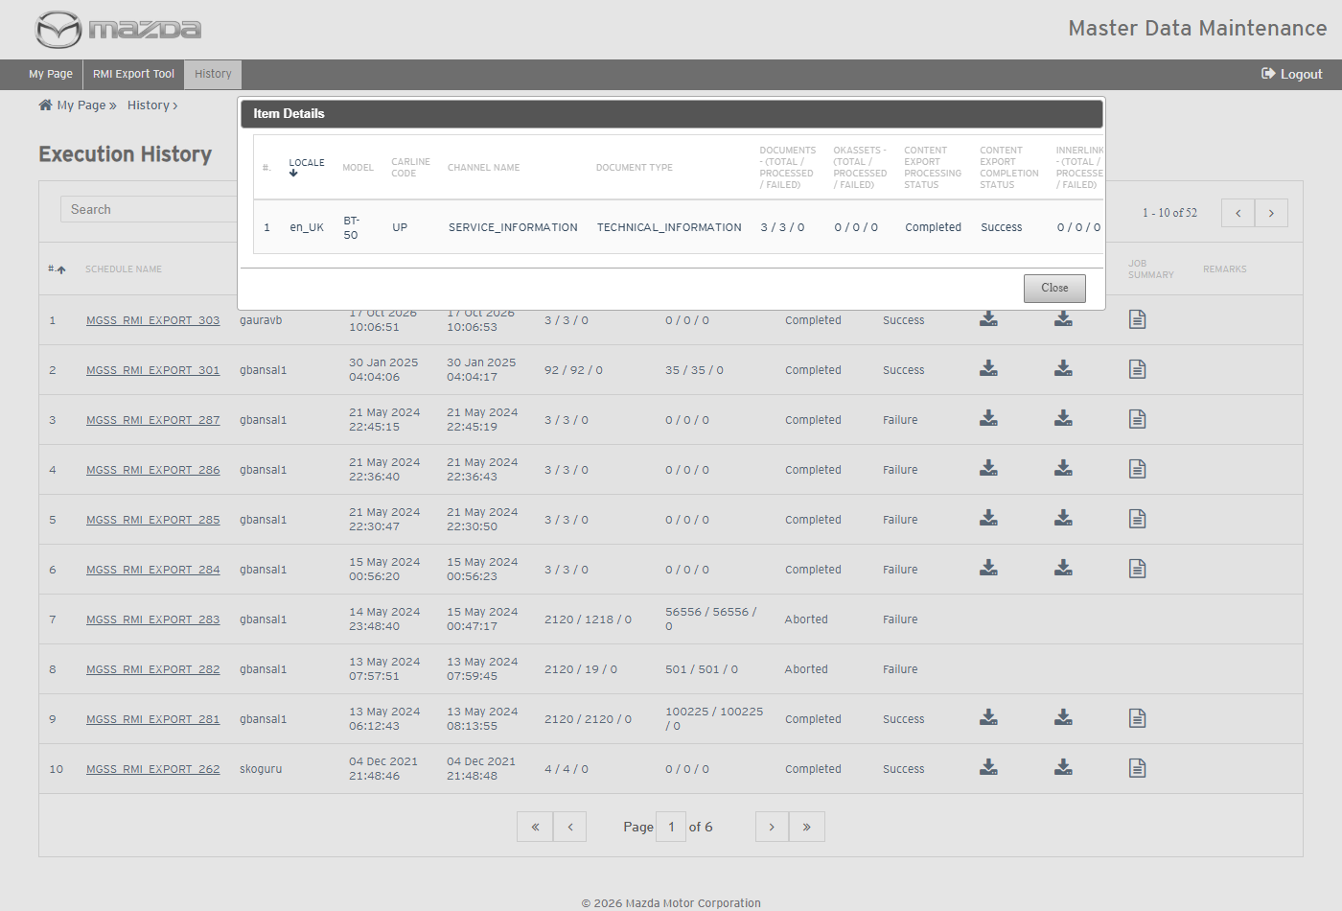
Item Details
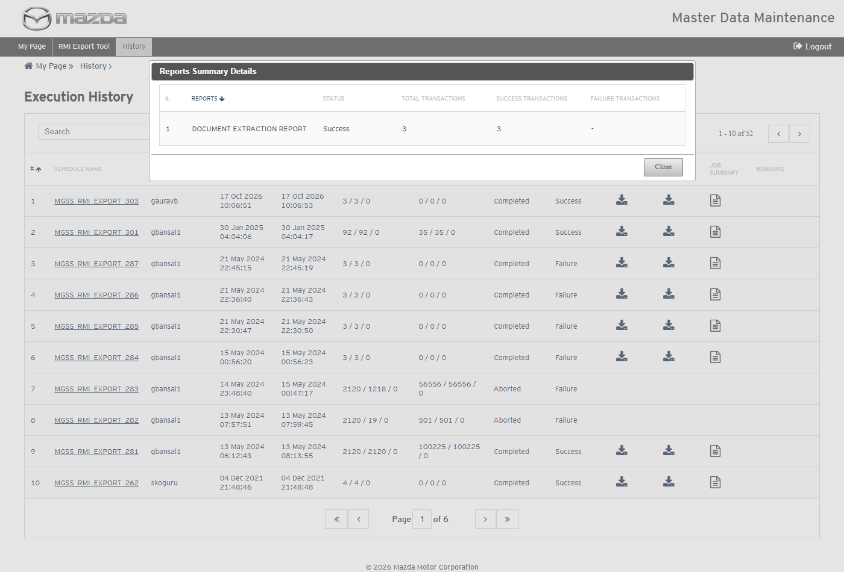
Reports Summary Details
Status: Pass
Remarks:

- User should be able to download the RMI export report and the extracted content.
Steps:
1. Click the Download Reports and Download XMLs icons of the schedule.
2. Open the files.
Expected Result:
- The Document Extraction Report lists SI1124, SI1141 and SI1143 with Processing Status Success.
- The XML zip holds one XML per document under locale / model / channel / document type, plus the view content details Excel.
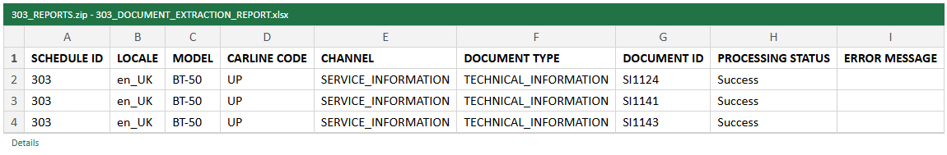
Document Extraction Report
Extracted content (XML zip)
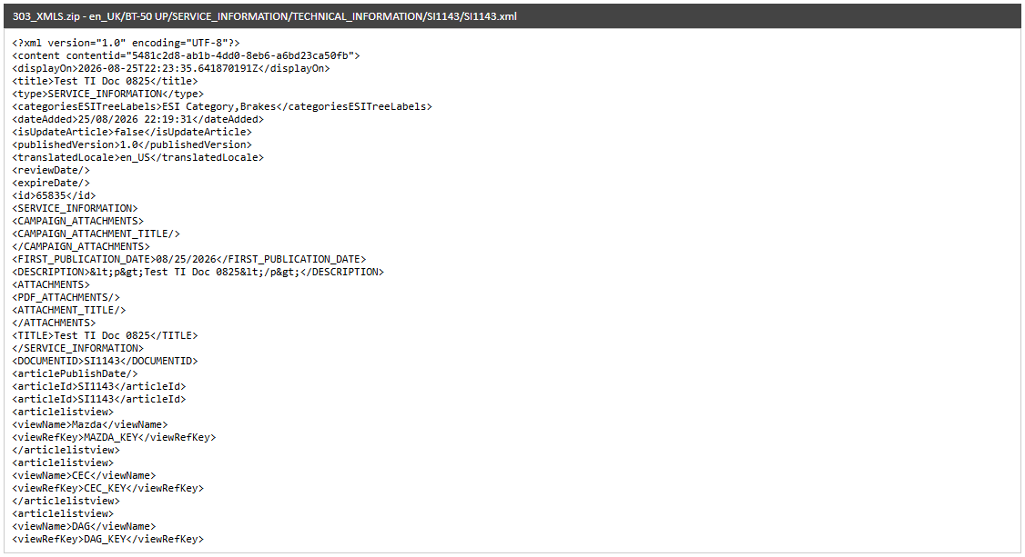
Extracted XML - SI1143
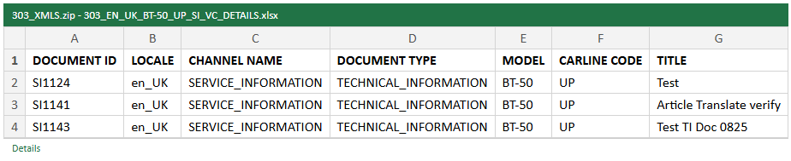
View content details
Status: Pass
Remarks:

Service Information Data Import
The cases below are executed with Country United States and Language English Us, importing the screen's Sample Document as a New Document.
- System should not upload without a Word file.
Steps:
1. From My Page > Tools, Import and Export, click Service Information Data Import.
2. Select the Country and Language and click Upload without a file.
Expected Result: "Please upload a valid Doc file." is shown.
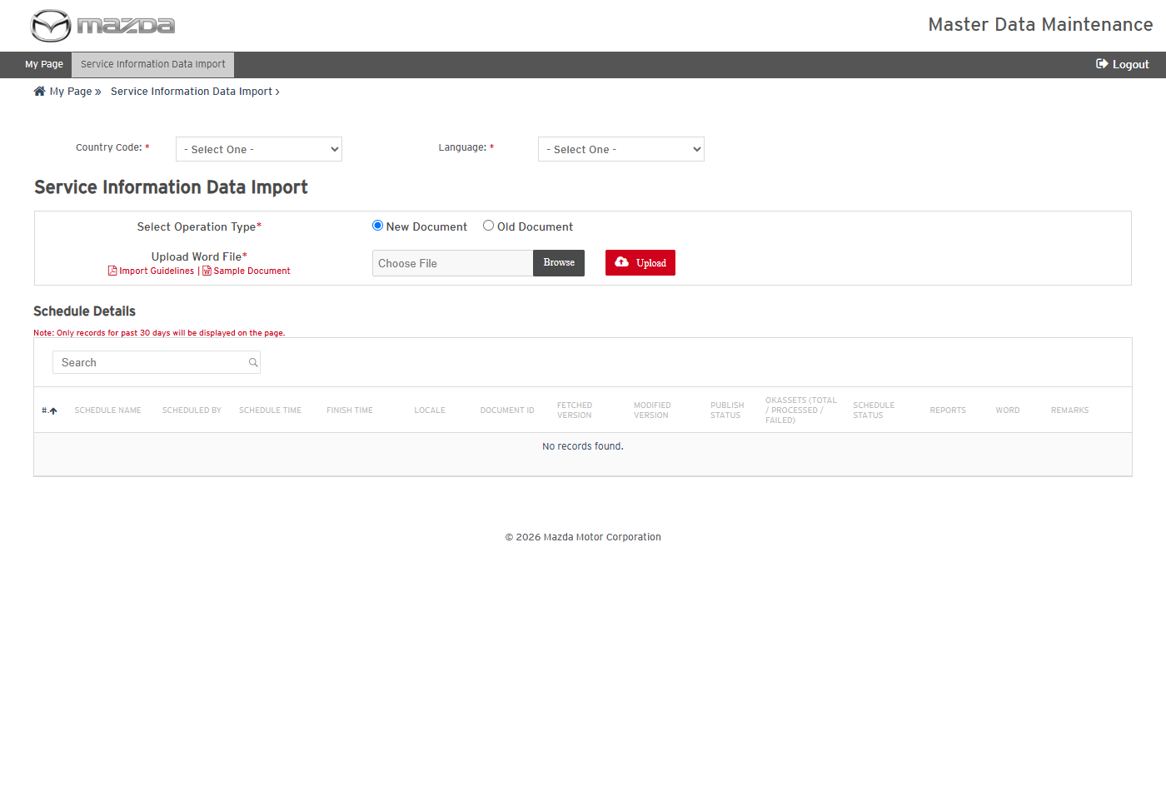
Service Information Data Import
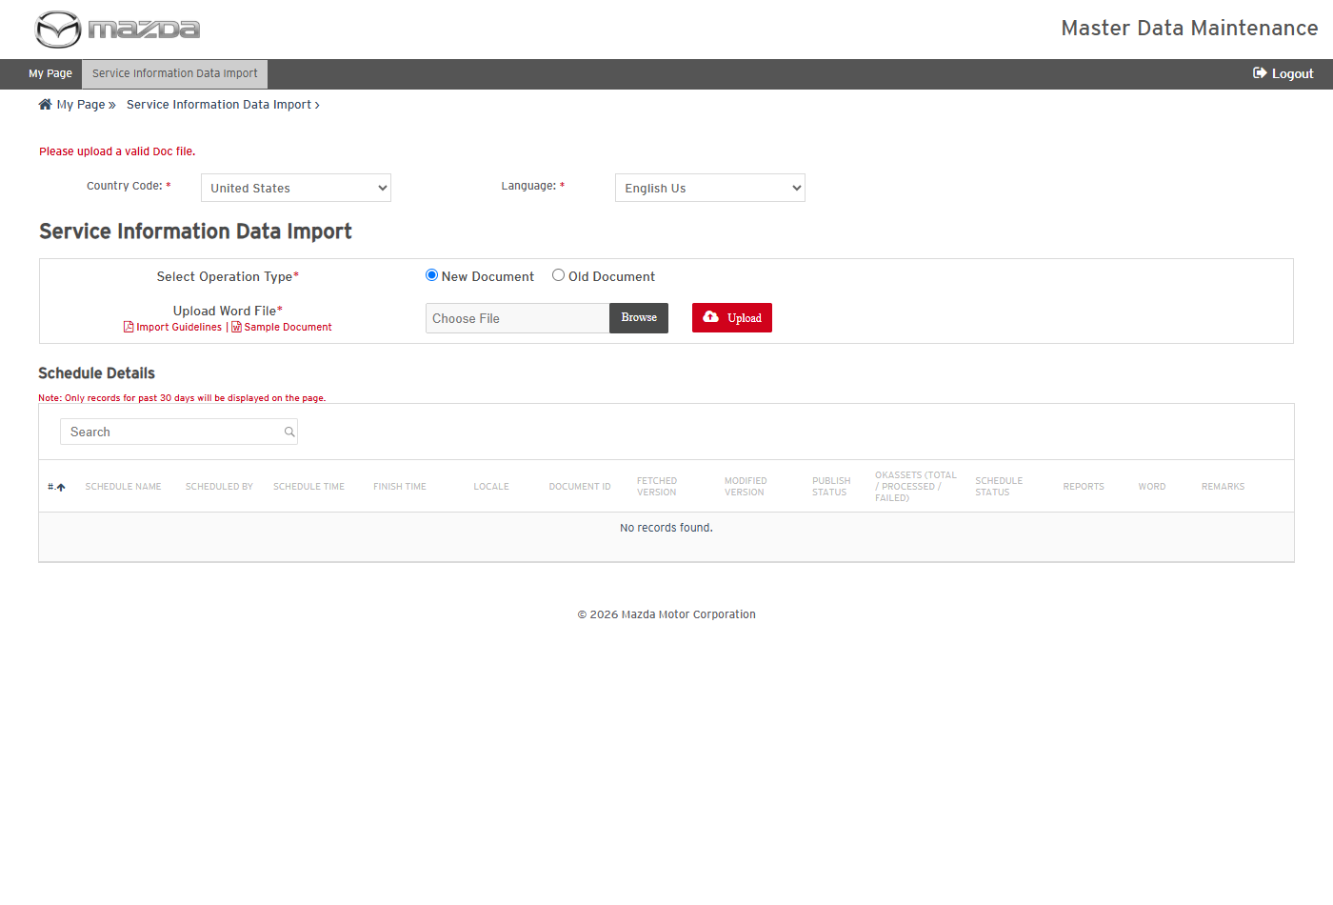
Validation message
Status: Pass
Remarks:

- User should be able to import a Word file as a new Service Information document.
Steps:
1. Select Operation Type New Document and choose the Word file (Sample Document).
2. Click Upload.
Expected Result:
- "SI_DL_SCH_93 scheduled successfully." is shown.
- The schedule completes with Document Id SI101014, Modified Version 0.1, Publish Status N and Schedule Status Success (the new document is saved as a draft for review and publishing).
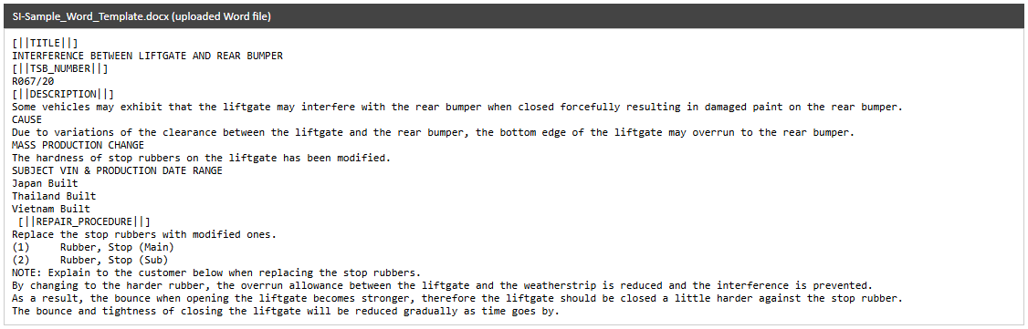
Uploaded Word file
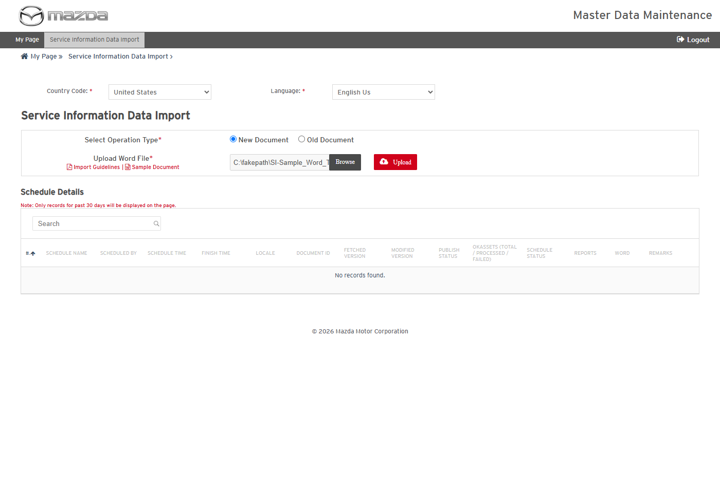
New Document selected
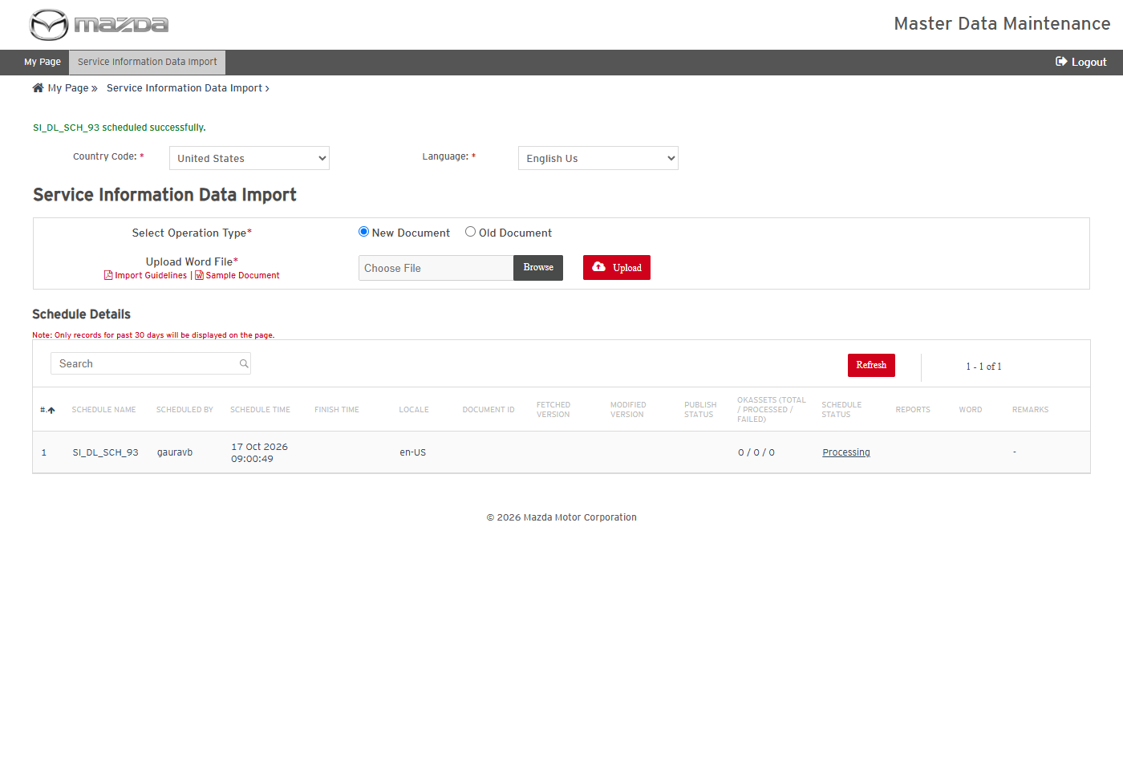
Import scheduled
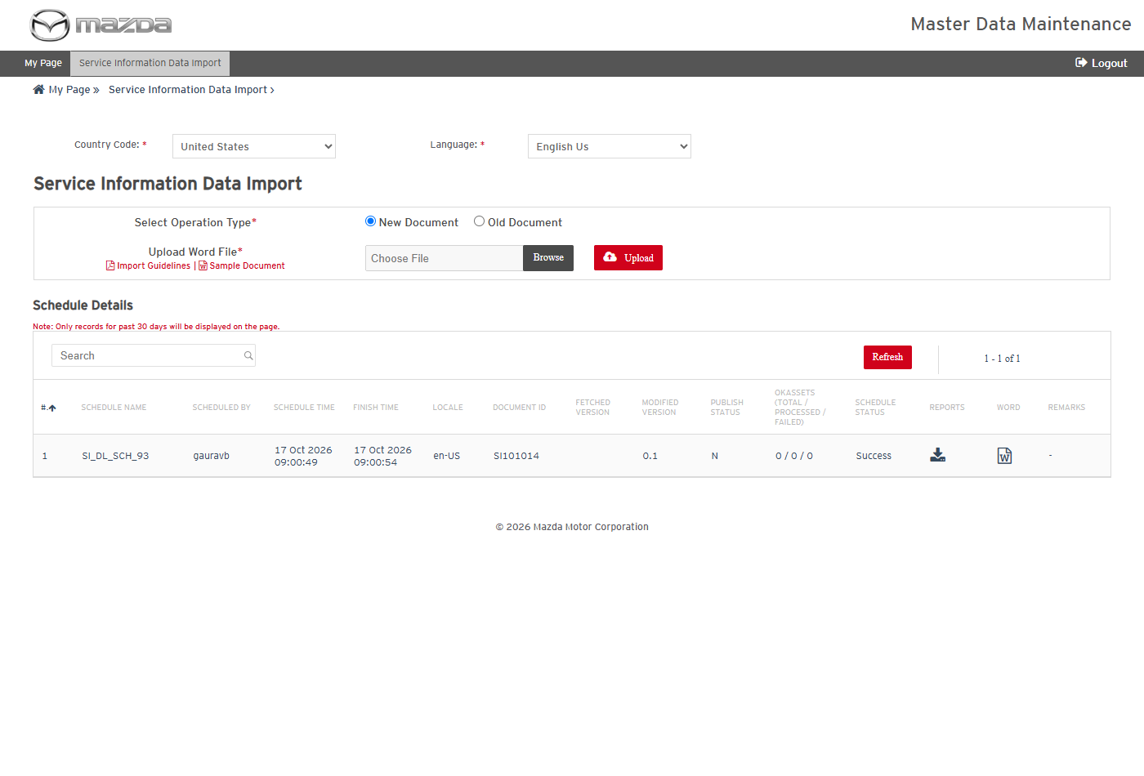
Import completed
Status: Pass
Remarks:

- User should be able to download the import report and the converted content.
Steps:
1. Click the Reports and Word icons of SI_DL_SCH_93.
2. Open the files.
Expected Result:
- The transaction report lists SI101014 (en-US, New Document, version 0.1) with Processing Status Success.
- The converted content shows the sections of the Word file (title, TSB number, description, repair procedure and others).
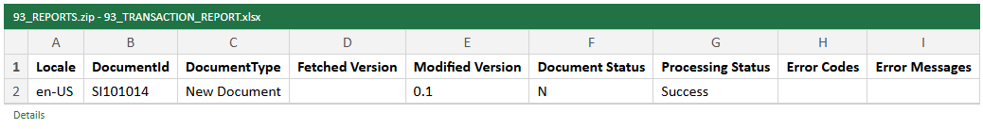
Transaction report
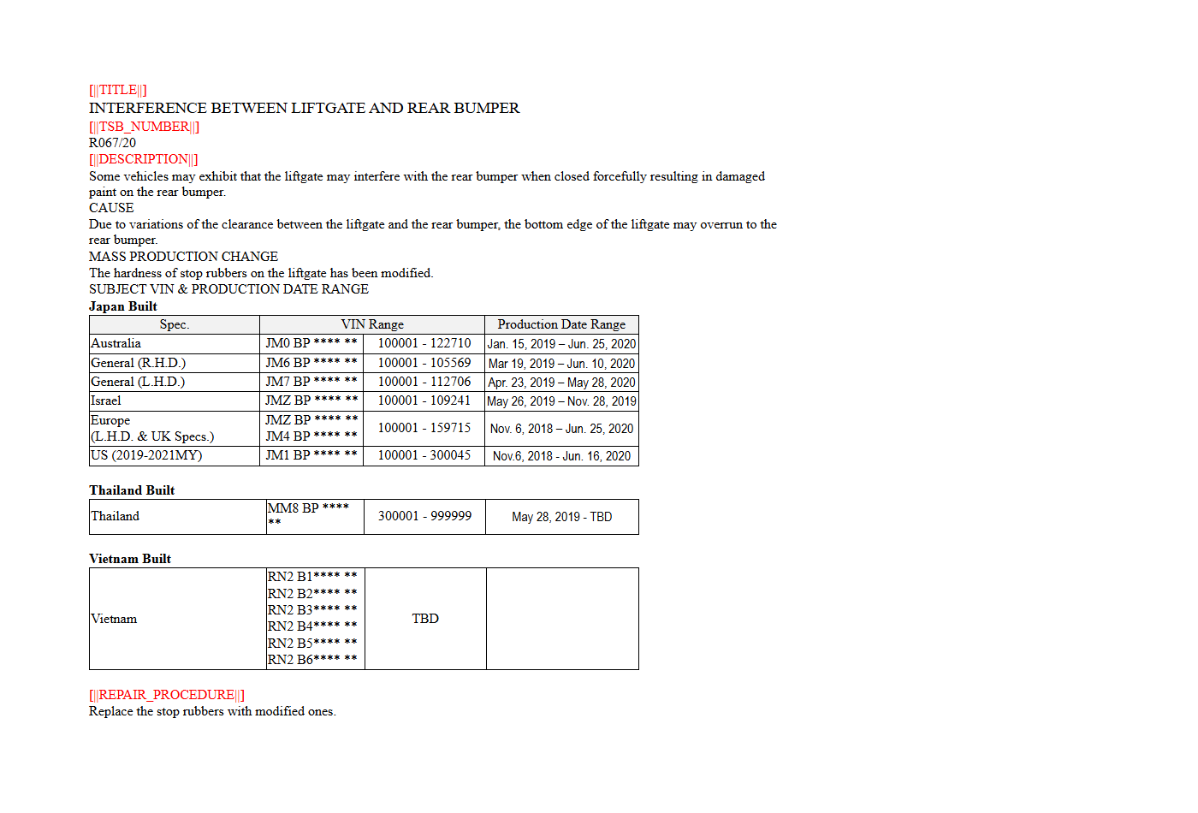
Converted content
Status: Pass
Remarks:

MNAO Data Export Tool
The cases below are executed with Country United States, Language English Us (en-US), Data Extraction Type Full Data and Model B1800.
- System should not list items without the mandatory fields.
Steps:
1. From My Page > Tools, Import and Export, click MNAO Data Export Tool.
2. Click Go.
Expected Result: "Please fill all the fields marked as mandatory (*)." is shown.
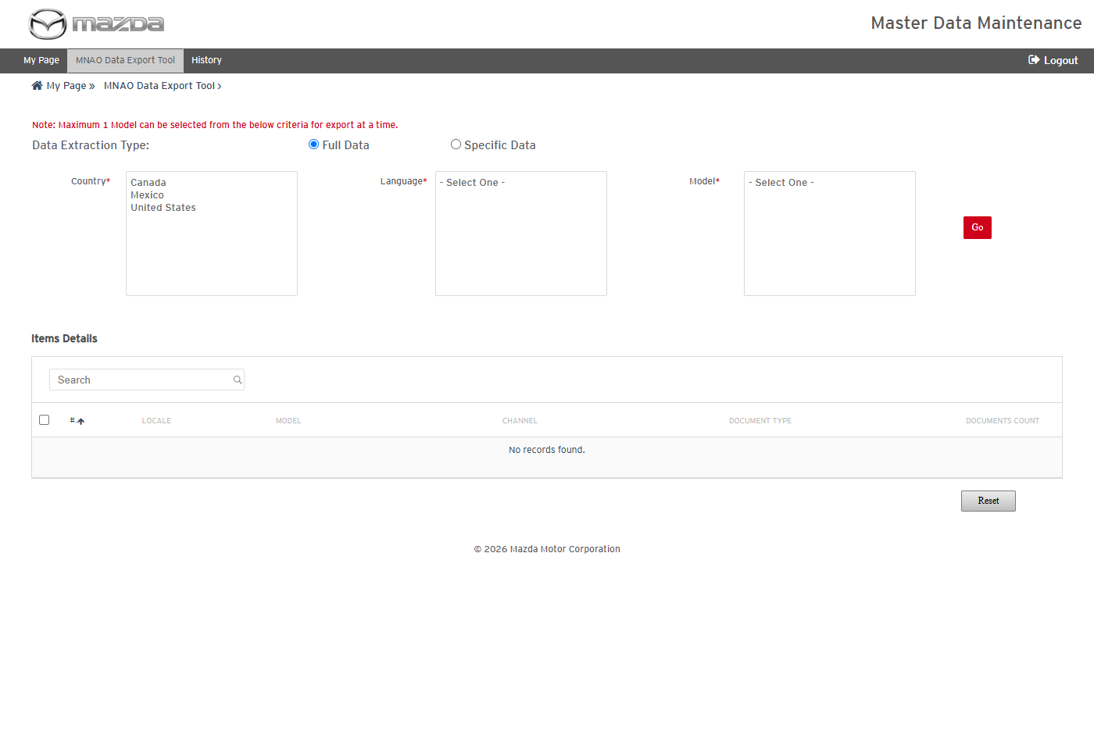
MNAO Data Export Tool
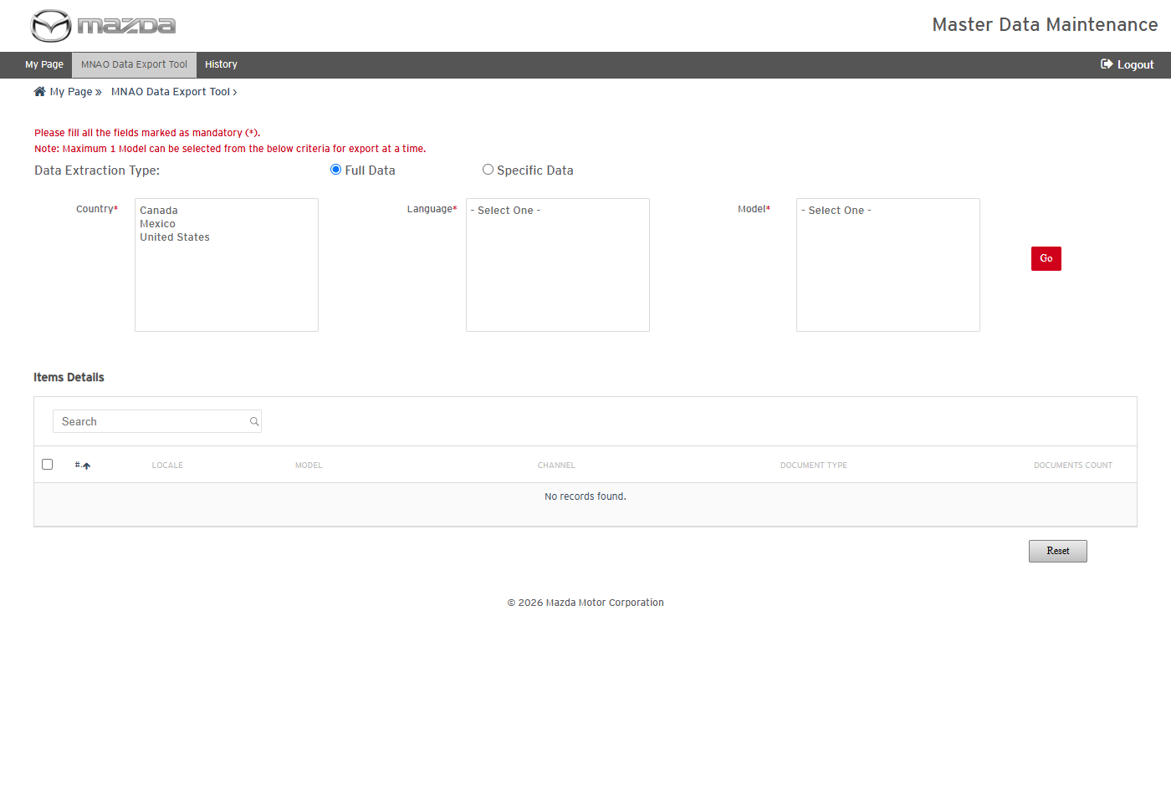
Mandatory field message
Status: Pass
Remarks:

- User should be able to list the items of a model and schedule an MNAO export.
Steps:
1. Select Country United States, Language English Us (en-US) and Model B1800; click Go.
2. Select the SERVICE_INFORMATION / SERVICE_ALERT item and click Schedule.
Expected Result:
- Items Details lists the channel / document type items of the model with their document counts.
- "Schedule MGSS_MNAO_EXPORT_B1800_32 scheduled successfully." is shown.
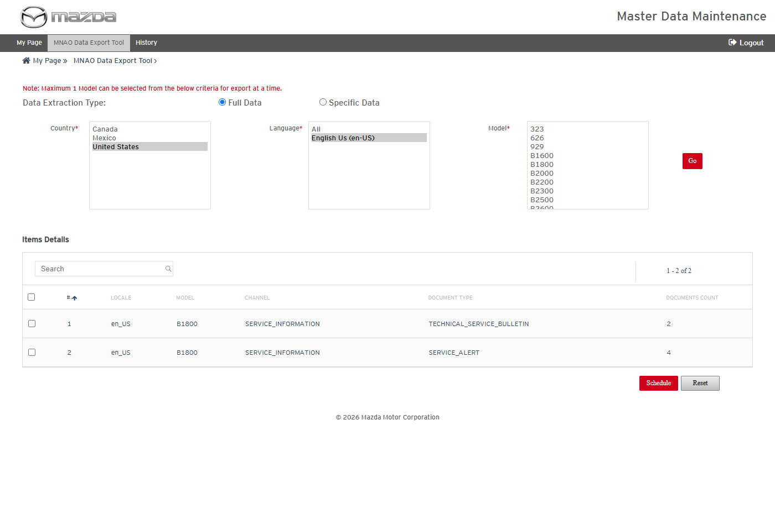
Items of B1800
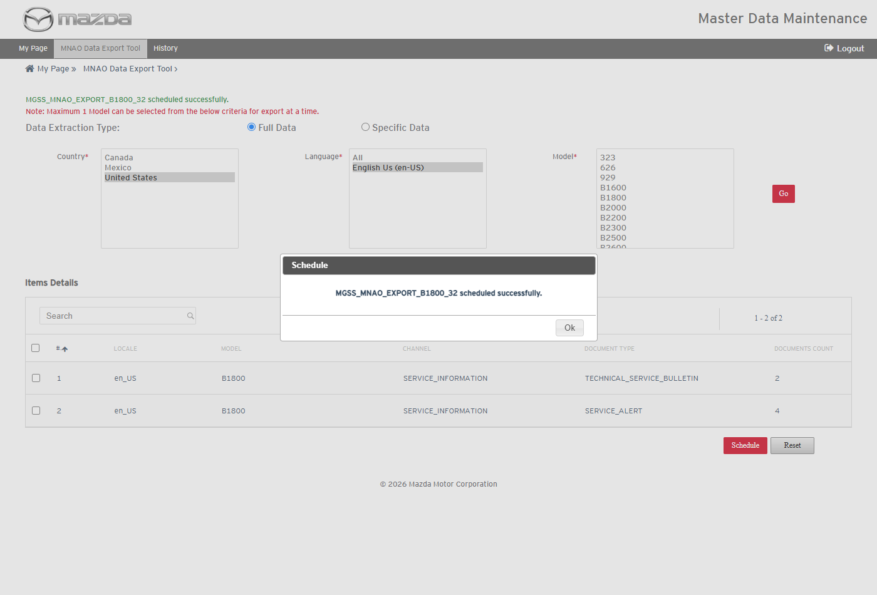
Export scheduled
Status: Pass
Remarks:

- User should be able to view the MNAO export history, item details and report summary.
Steps:
1. Click History in the top menu.
2. Click the schedule name, then the Job Summary icon.
Expected Result:
- MGSS_MNAO_EXPORT_B1800_32 shows Documents 4 / 4 / 0, OKAssets 2 / 2 / 0, Content Export Progress Completed and Job Status Success.
- Reports Summary Details shows the Document Extraction (4), Files Transaction (2) and Inner Links Transaction (8) reports, all Success.
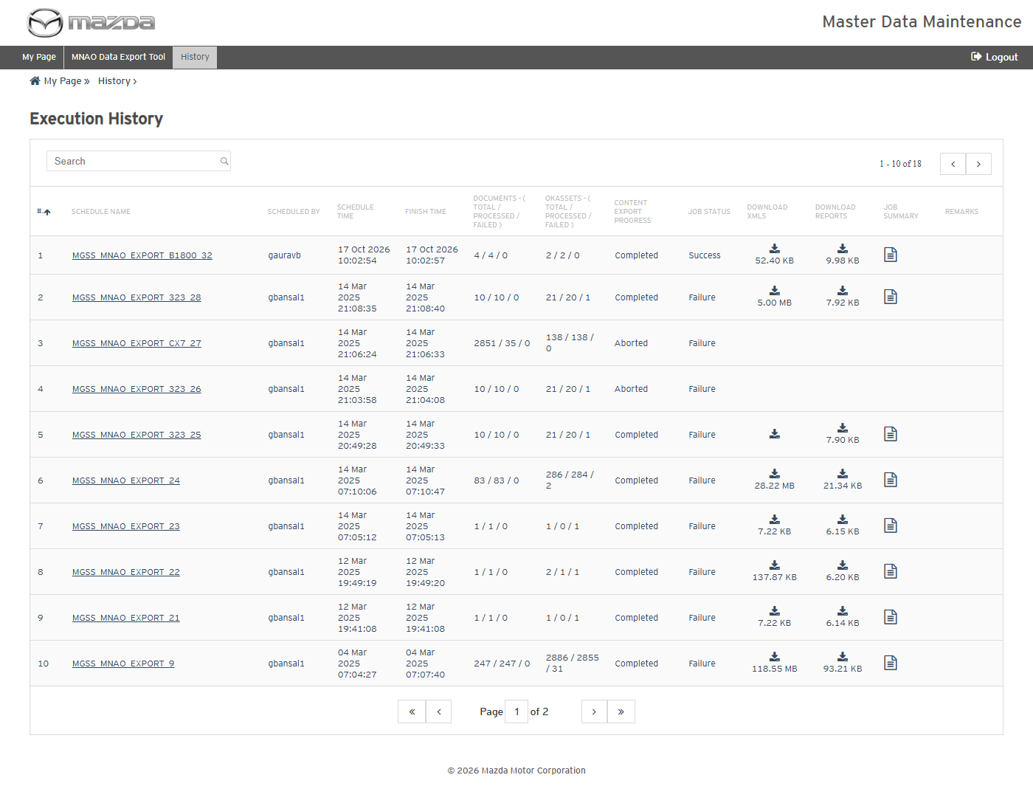
MNAO Export History
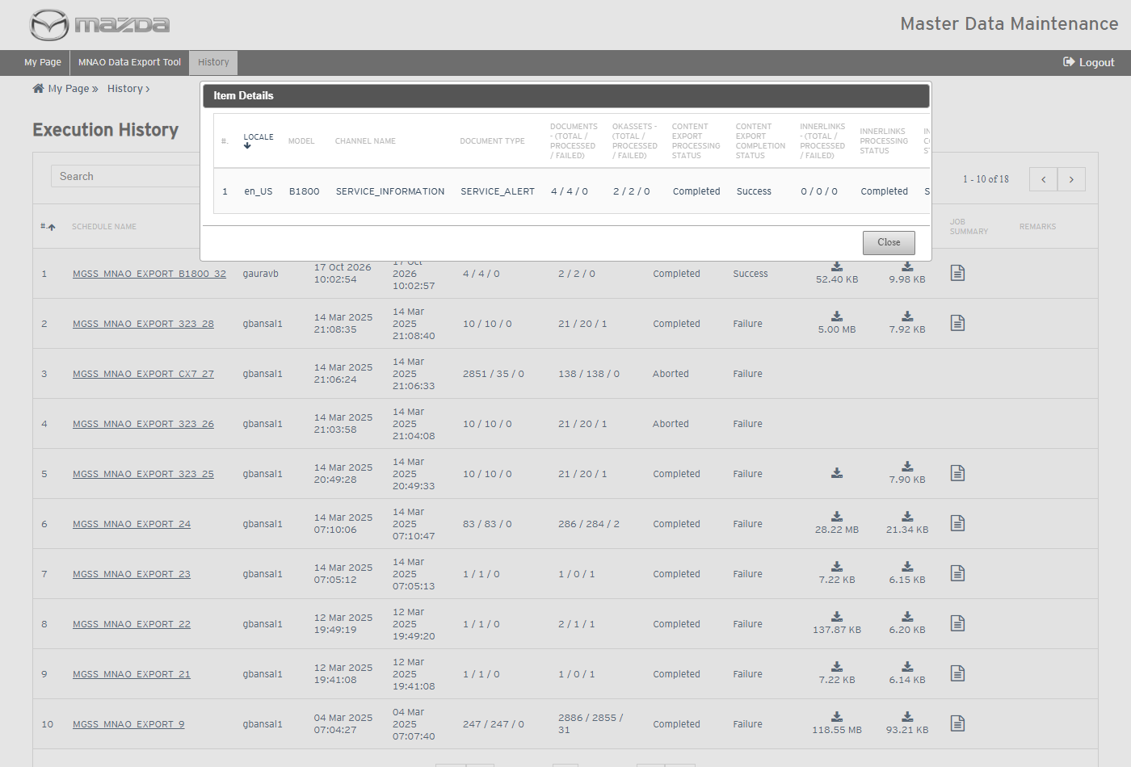
Item Details
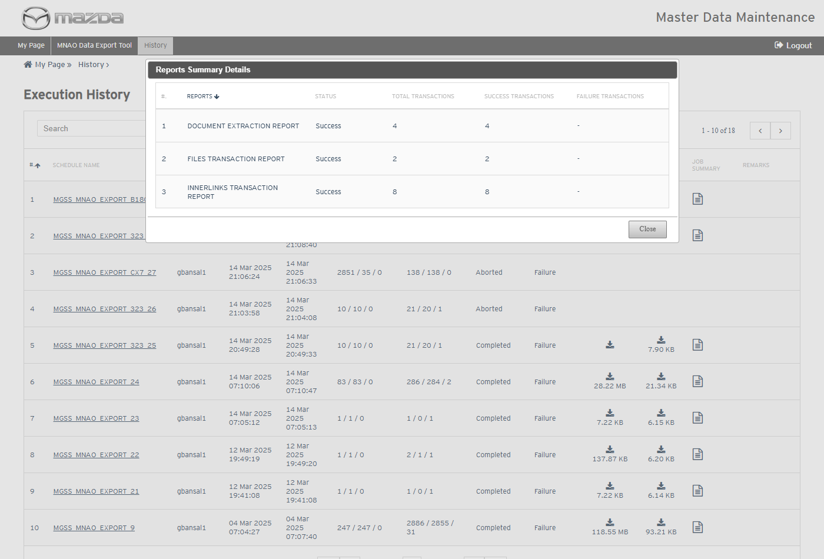
Reports Summary Details
Status: Pass
Remarks:

- User should be able to download the MNAO export reports and the extracted content.
Steps:
1. Click the Download Reports and Download XMLs icons of the schedule.
2. Open the files.
Expected Result:
- The reports list the 4 documents, the 2 images and the inner links with Processing Status Success.
- The XML zip holds one XML per document (image paths rewritten to the exported OkAssets folder), the exported images and the view content model year / VIN details.
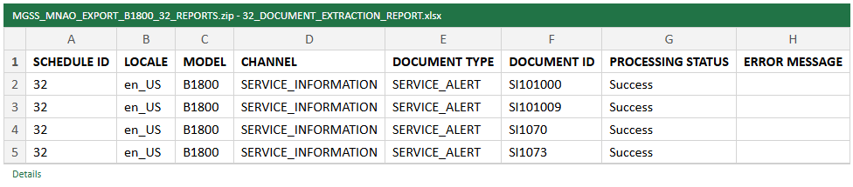
Document Extraction Report
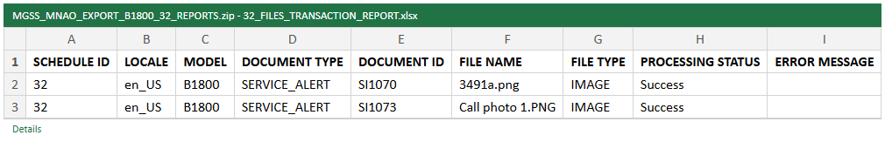
Files Transaction Report
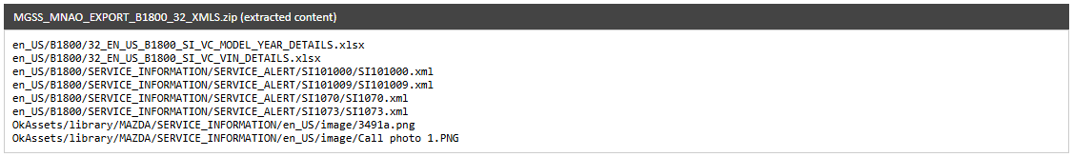
Extracted content (XML zip)
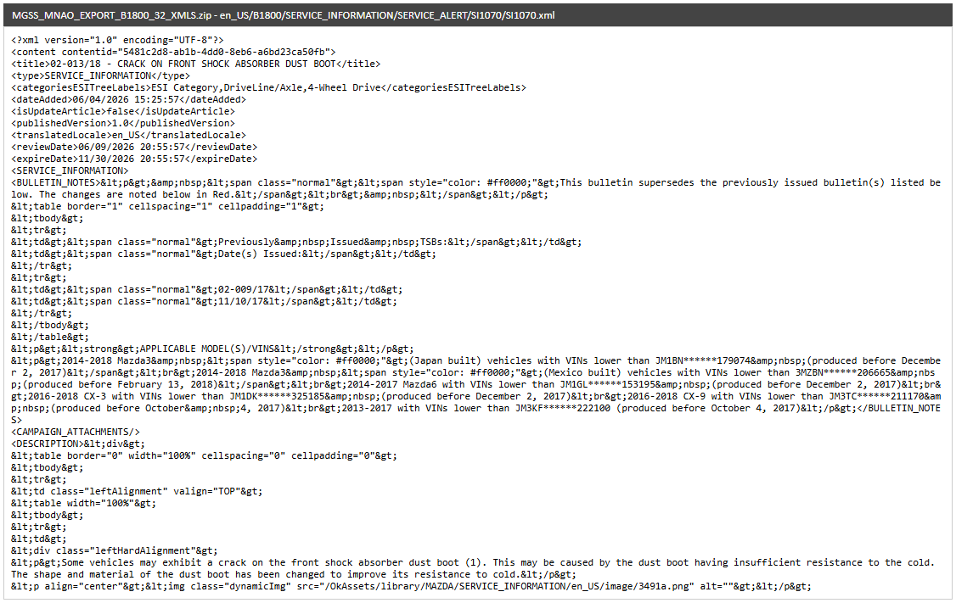
Extracted XML - SI1070
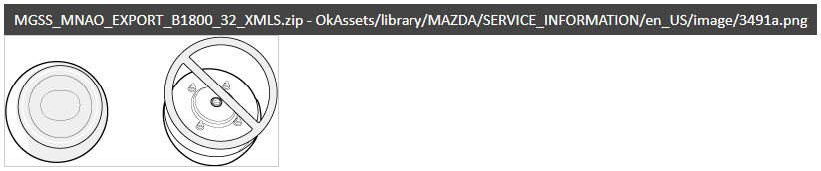
Exported image - 3491a.png
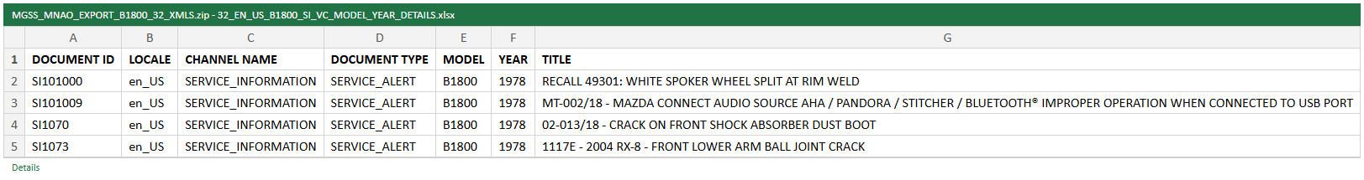
View content model year details
Status: Pass
Remarks:

MGSS Bulk Data Extract & Transfer Tool
- User should be able to view the auto scheduler settings and model details.
Steps:
1. From My Page > Tools, Import and Export, click MGSS Bulk Data Extract & Transfer Tool.
Expected Result: Auto Scheduler Settings (Day / Hour) and Model Details list each EN_US model with its schedule time, last executed time and the Run On Demand / Reset For Full Extract / Update For Delta Extract actions.
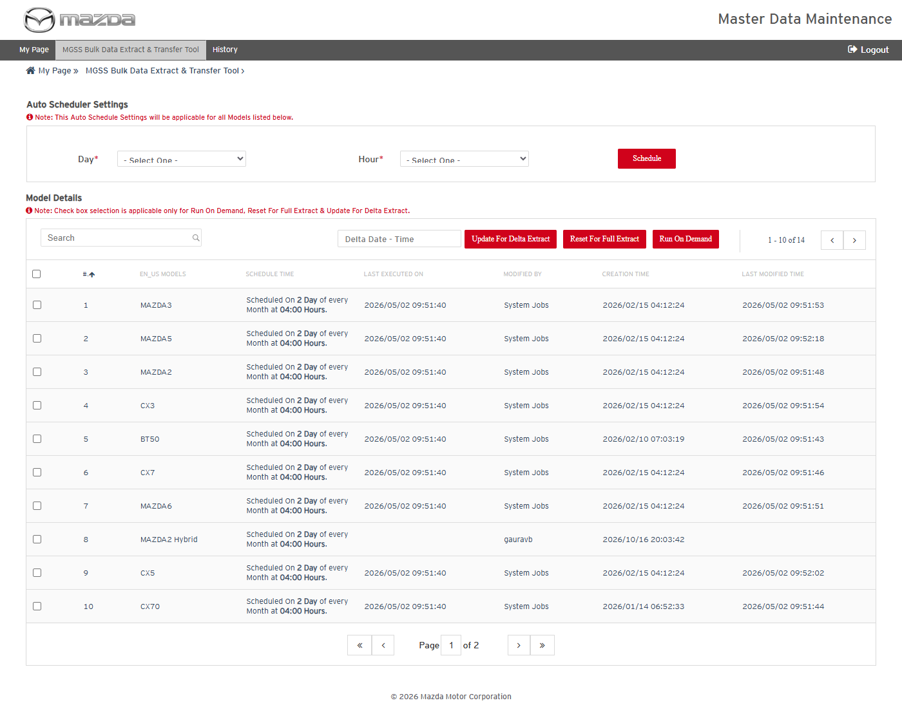
MGSS Bulk Data Extract & Transfer Tool
Status: Pass
Remarks:

- System should not save the auto schedule without Day and Hour.
Steps:
1. Leave Day and Hour as - Select One - and click Schedule.
Expected Result: "Please fill all the fields marked as mandatory (*)." is shown.
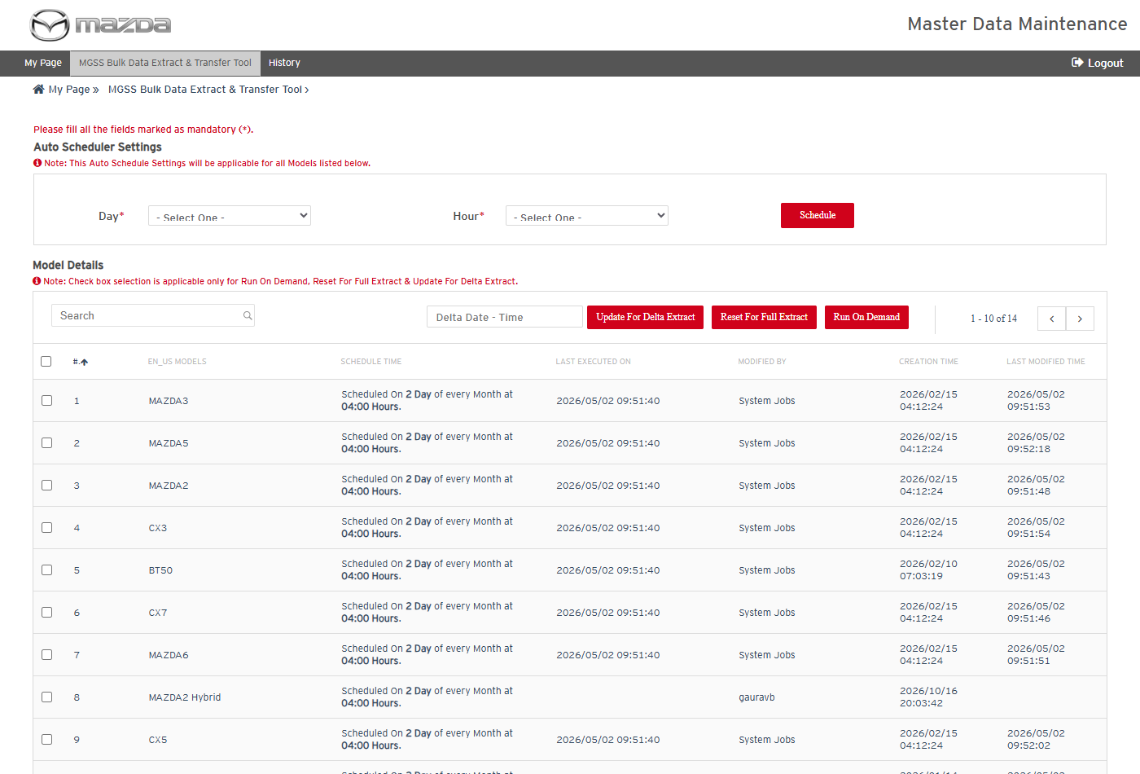
Mandatory field message
Status: Pass
Remarks:

- System should not change the auto schedule while extraction jobs are running.
Pre-condition: Extraction jobs are in progress for models listed on the screen.
Steps:
1. Select Day 2 and Hour 04:00.
2. Click Schedule.
Expected Result: "Data Extraction Jobs are running for the below Models. Auto Schedule Settings operation not allowed." is shown and the schedule is not changed.
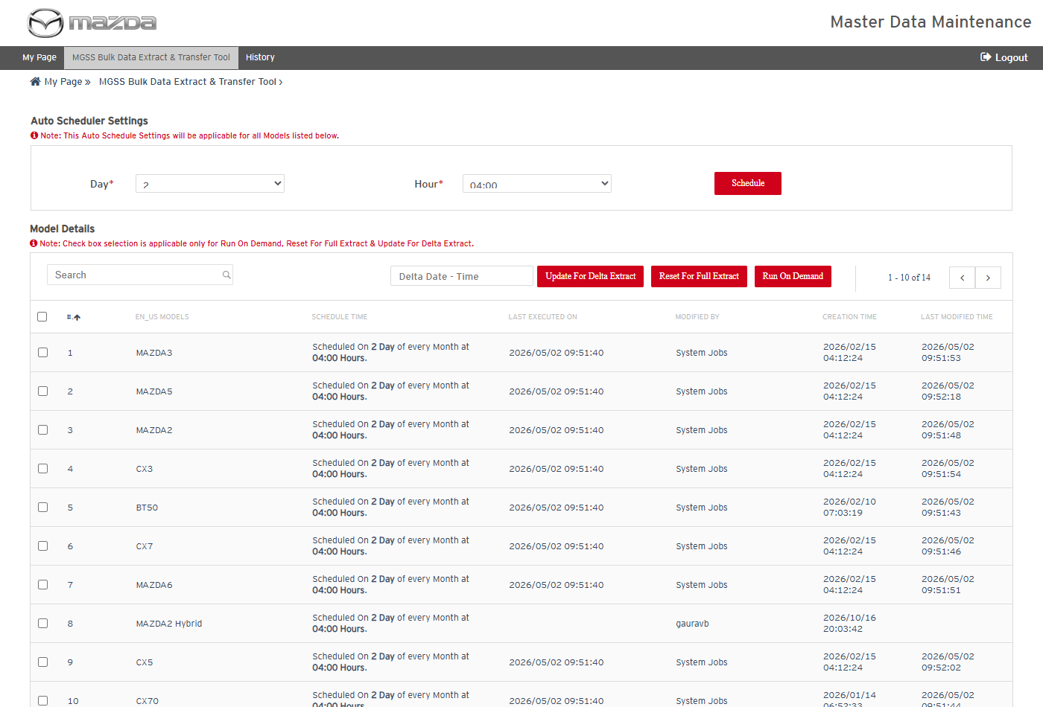
Day and Hour selected
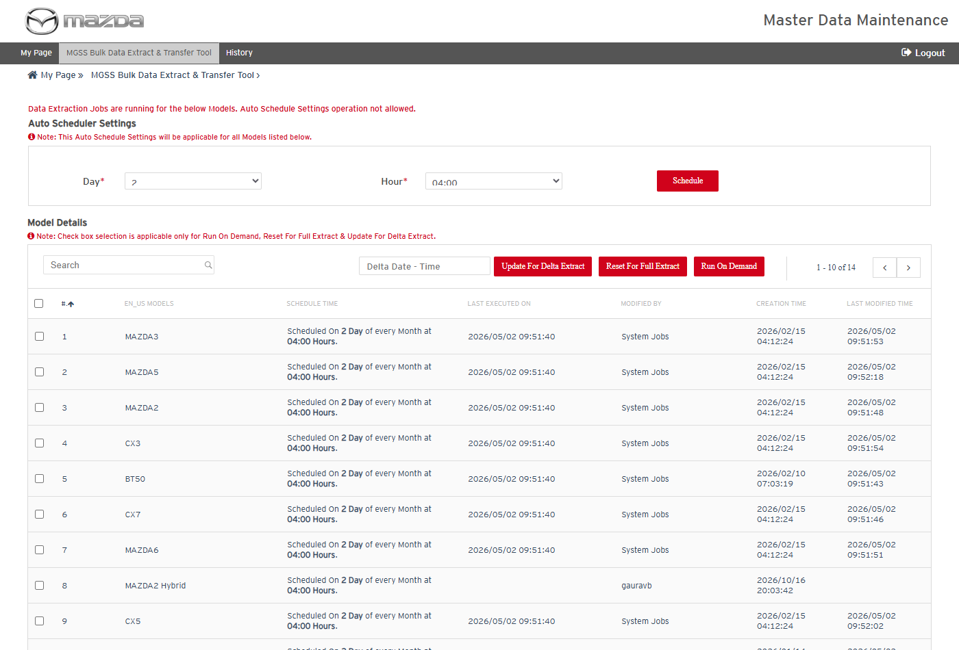
Schedule not allowed
Status: Pass
Remarks:

- System should not run on demand without a model selected.
Steps:
1. Click Run On Demand without selecting a model.
Expected Result: "Please select at least one row." is shown.
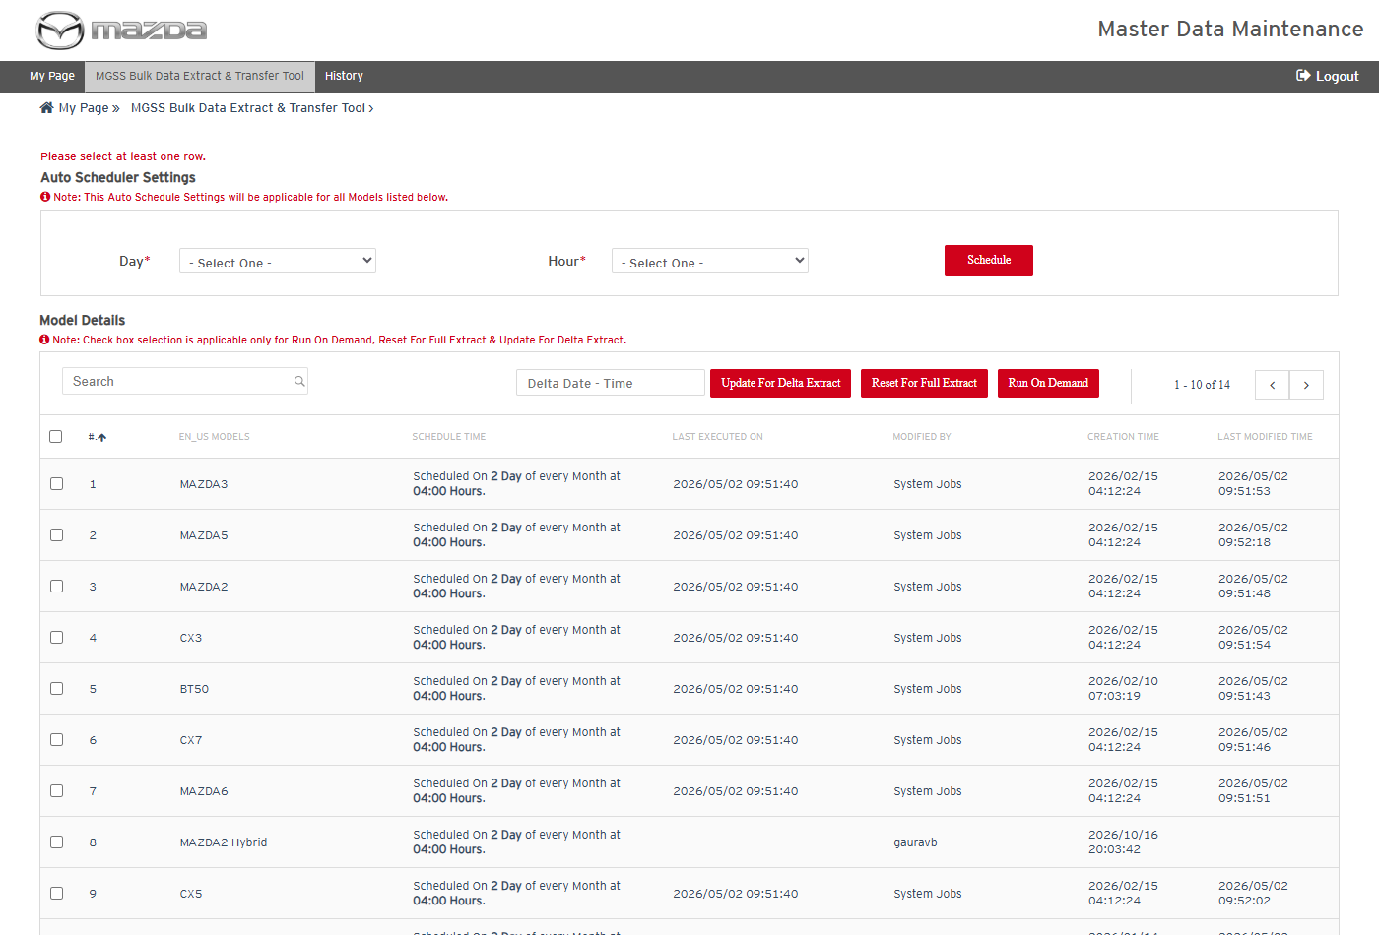
Select a row message
Status: Pass
Remarks:

- User should be able to request an on demand extraction for a model.
Steps:
1. Select model CX5.
2. Click Run On Demand.
Expected Result:
- "On Demand Extraction scheduled successfully for selected Models. On Demand Job will run within 5 minutes to start the data extraction." is shown.
- A request row for CX5 is added to gms3_mdm_nmd_job_rod; the Run On Demand Job picks it up (see section MGSS Bulk Data - Run On Demand Job).
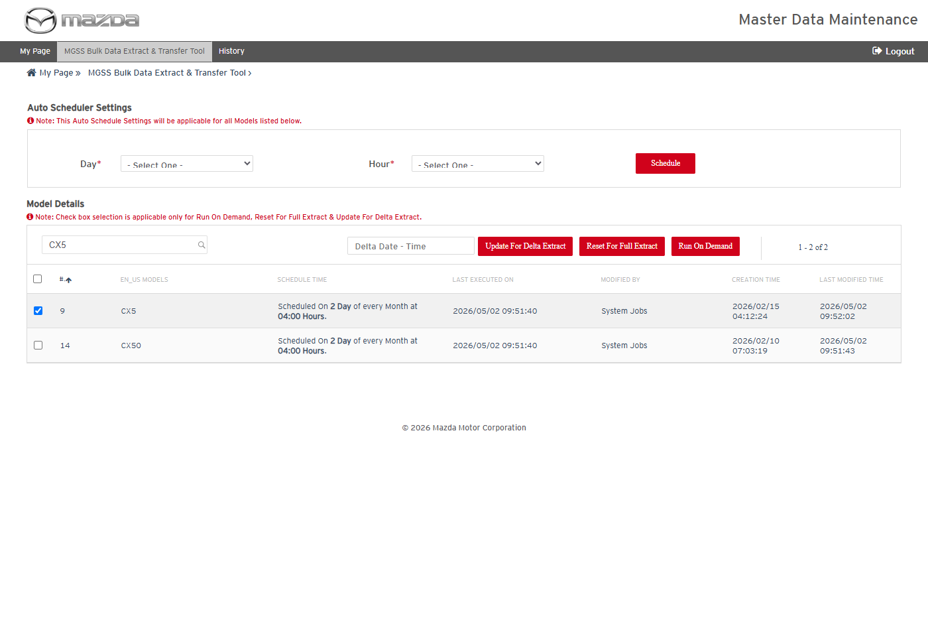
CX5 selected
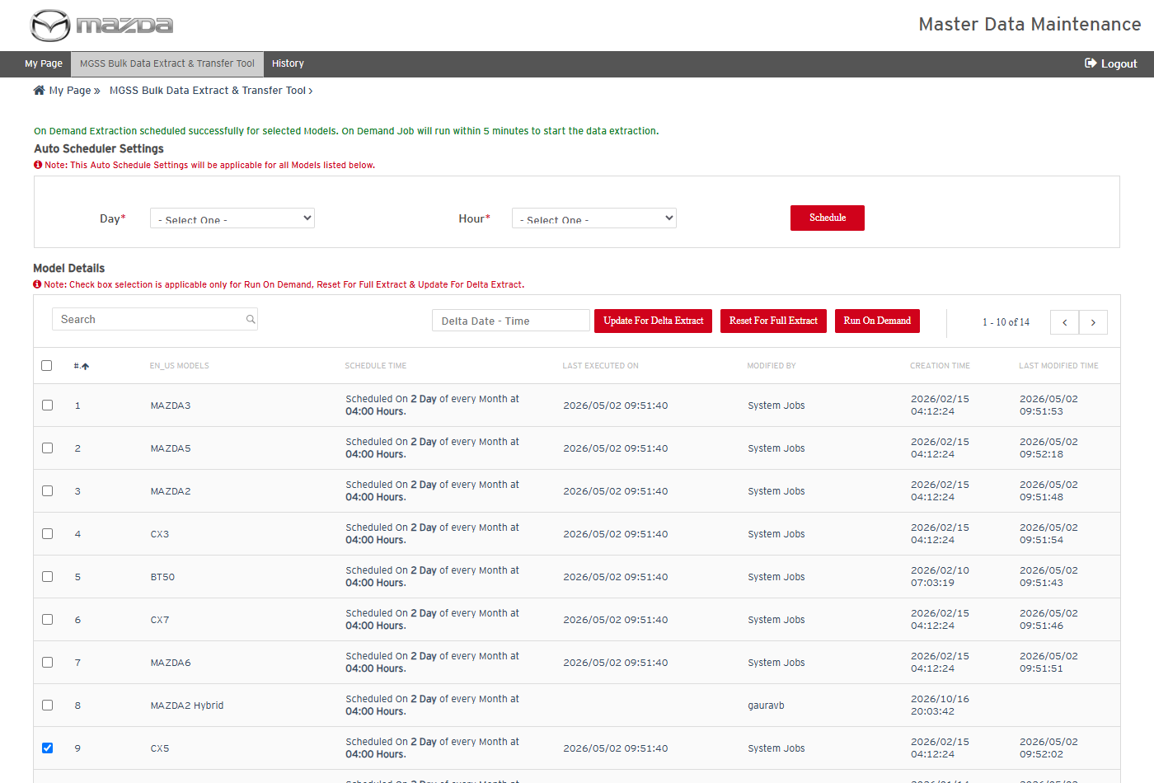
On demand scheduled
Status: Pass
Remarks:

- User should be able to update the last execution time for the delta extract.
Steps:
1. Select model CX5 and enter Delta Date - Time 20-04-26 00:00 (earlier than the last executed time).
2. Click Update For Delta Extract and click Yes on the confirmation.
Expected Result:
- The confirmation asks for MC Business approval.
- "Last Execution Time updated successfully for selected Models." is shown and CX5 Last Executed On becomes 2026/04/20 00:00:00, so the next delta extract starts from that time.
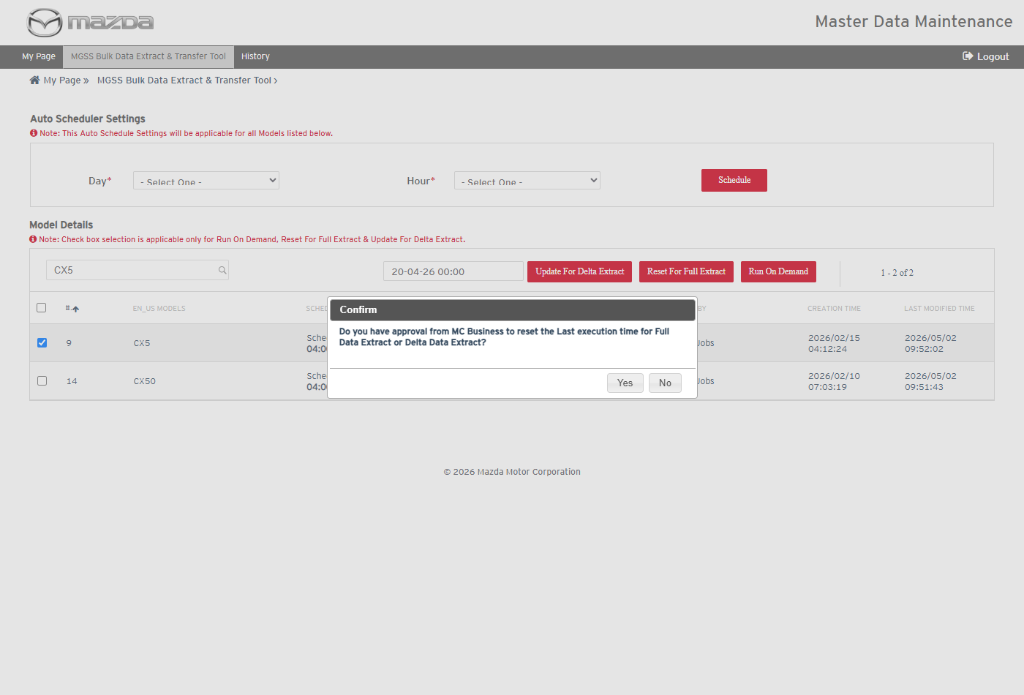
Confirmation
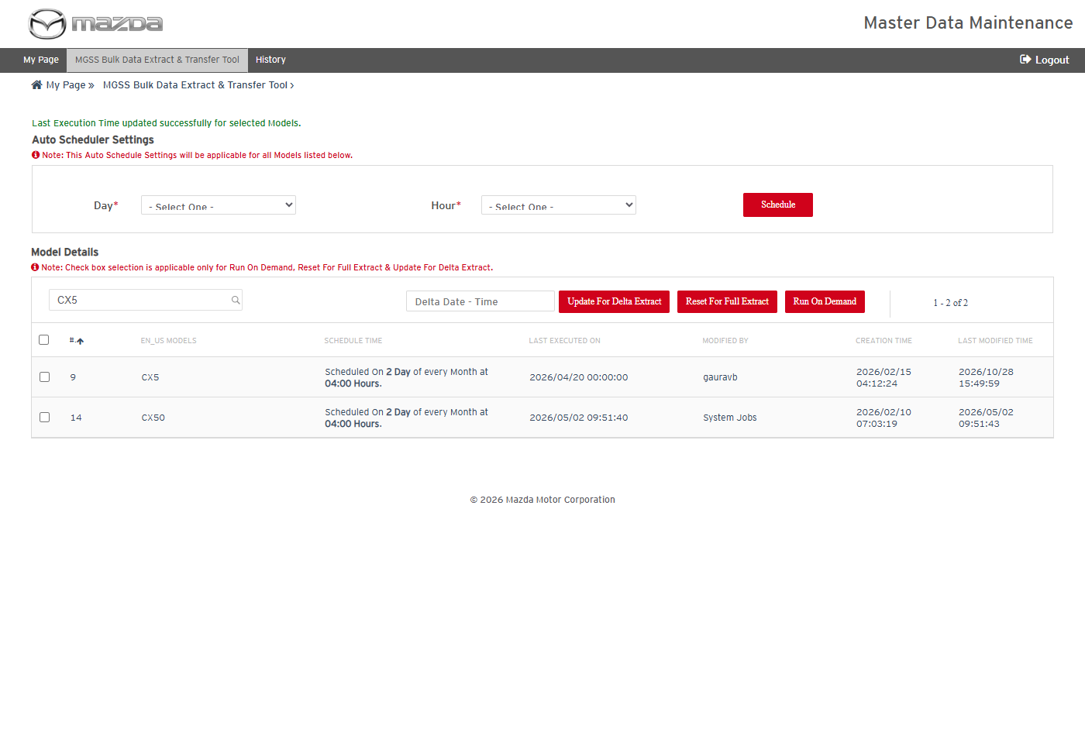
Last execution time updated
Status: Pass
Remarks:

- User should be able to reset the last execution time for a full extract.
Steps:
1. Select model CX5.
2. Click Reset For Full Extract and click Yes on the confirmation.
Expected Result: "Last Execution Time reset successfully for selected Models." is shown and CX5 Last Executed On is cleared, so the next extract of CX5 is a full extract.
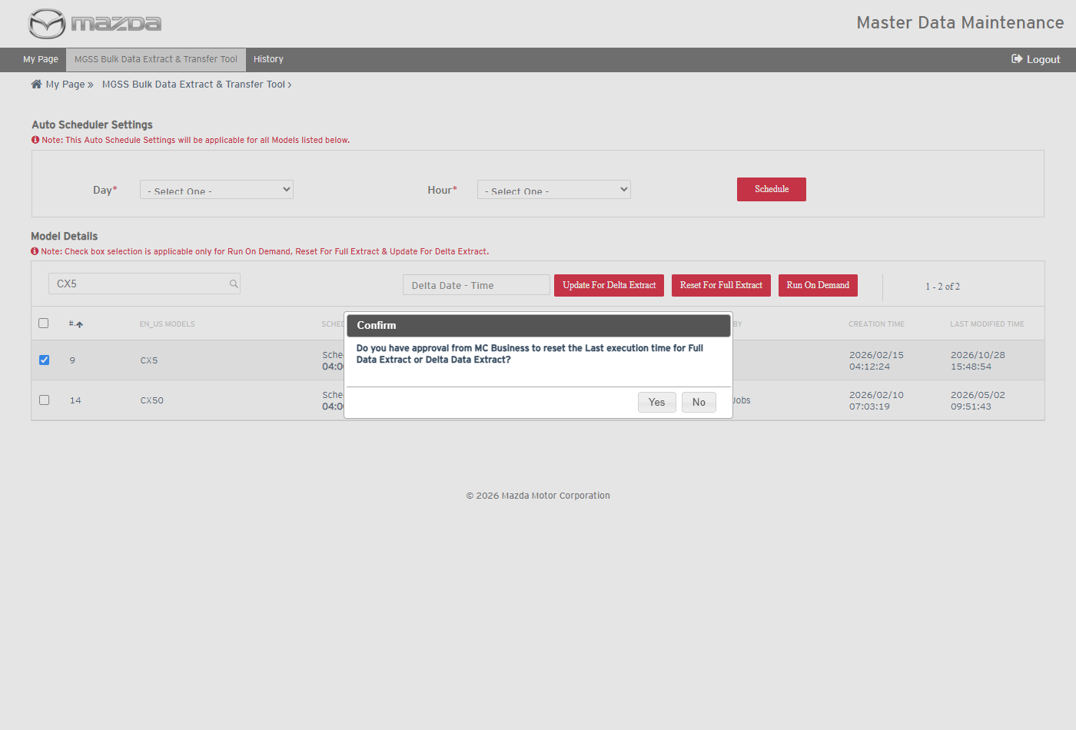
Confirmation
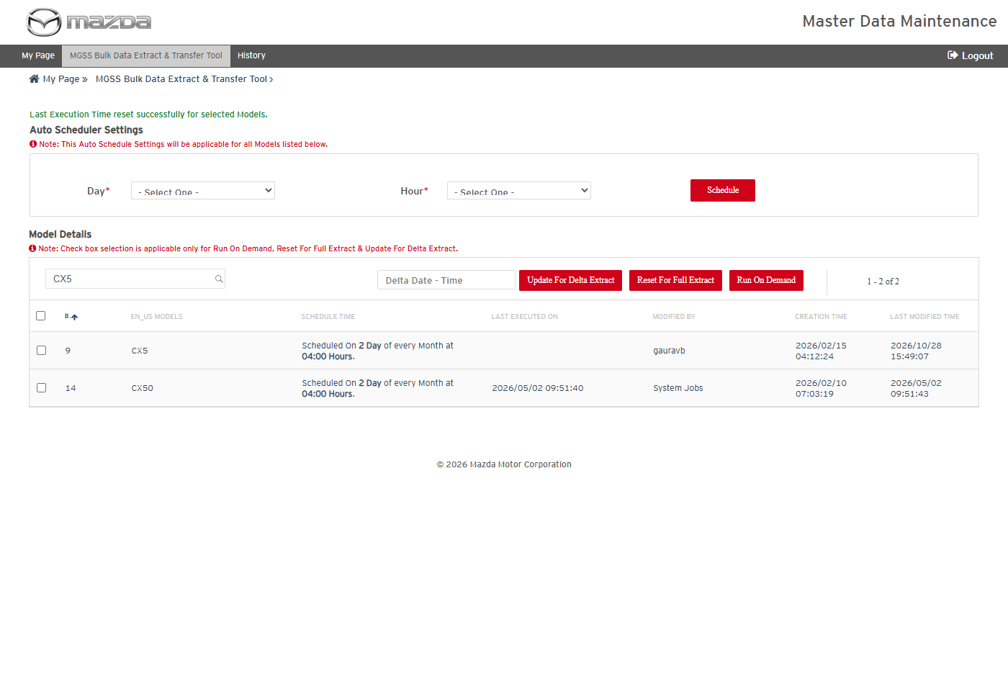
Last execution time reset
Status: Pass
Remarks:

- System should not update the delta extract time for a model without a last execution time.
Steps:
1. After the reset, select CX5, enter a Delta Date - Time and click Update For Delta Extract, then Yes.
Expected Result: "Last Execution Time is Blank for Model CX5. Update For Delta Extract operation not allowed." is shown.
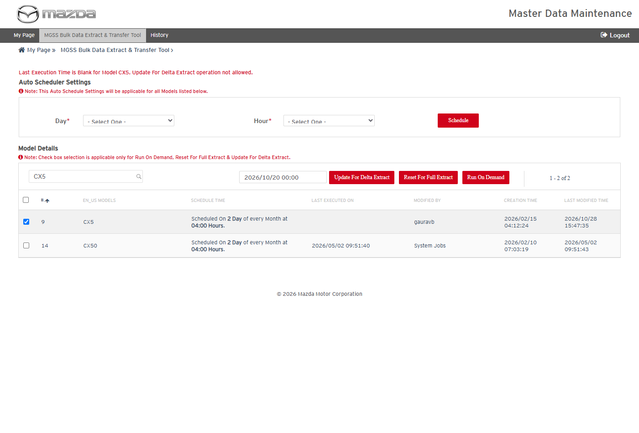
Update not allowed
Status: Pass
Remarks:

- User should be able to search the extract and transfer history.
Steps:
1. Click History in the top menu.
2. Enter From Date 2026-05-01, To Date 2026-05-03 and click Search.
Expected Result: Execution History lists the extract and transfer jobs of the period with documents, inner links, OKAssets, delete and transfer counts, job running status, data status, attempts, reports and summary.
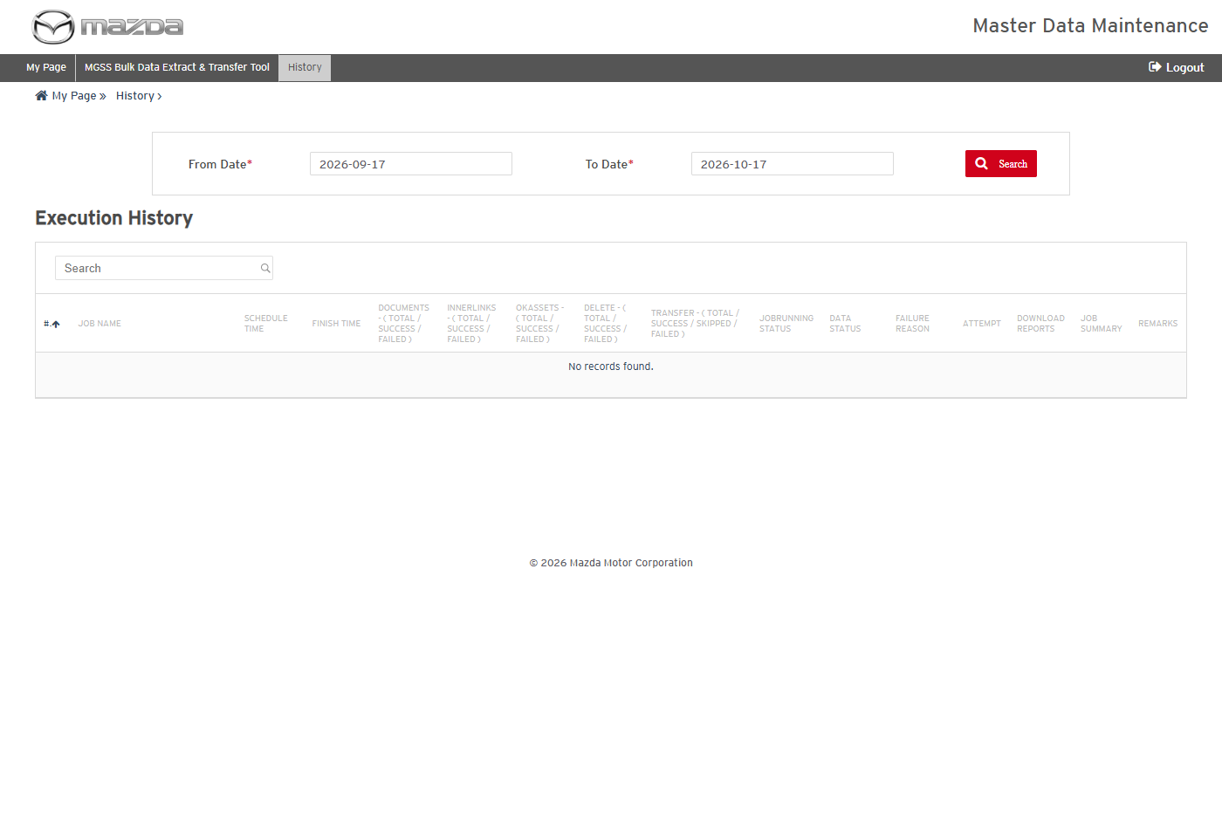
Execution History
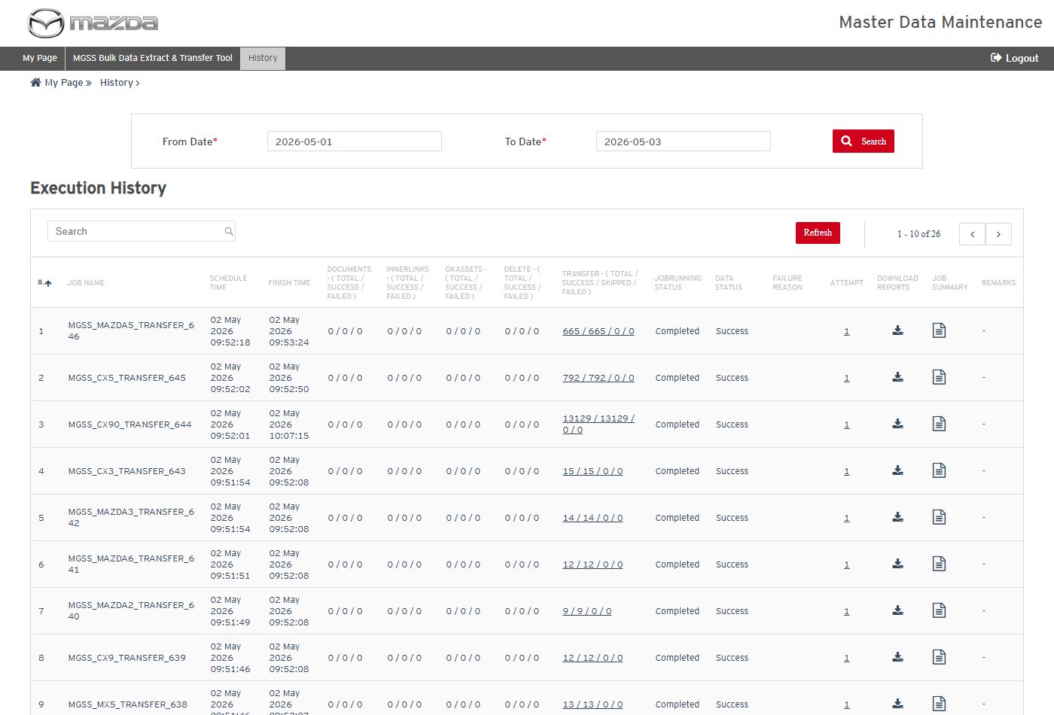
Search result
Status: Pass
Remarks:

- User should be able to view the attempt, transfer and report summary details of a job.
Steps:
1. Click the Attempt count of MGSS_CX5_TRANSFER_645.
2. Click the Transfer count of MGSS_CX5_TRANSFER_645.
3. Click the Job Summary icon of MGSS_CX70_EXT_630.
Expected Result:
- Item Details lists the attempts of the job with their counts and statuses.
- Transfer Summary Details lists the OCI folders (DELTA_DATA_DEV, FULL_DATA_DEV) with total / success / failure / skipped and delete counts (FULL_DATA_DEV 792 / 792).
- Reports Summary Details lists the documents, OKAssets and inner link reports with their status and counts.
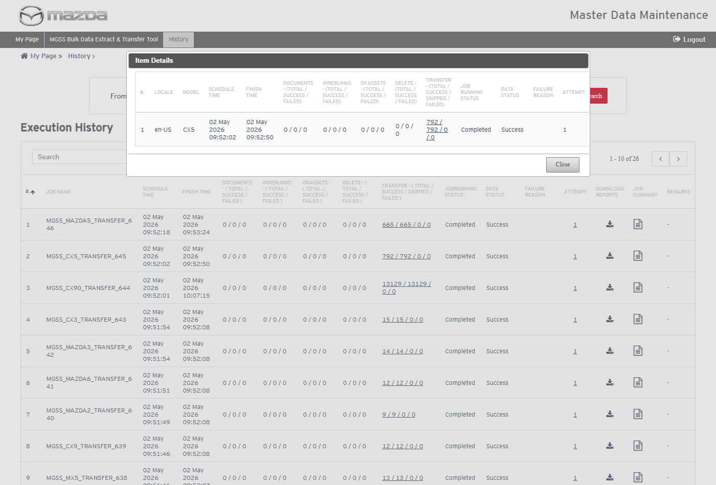
Item Details
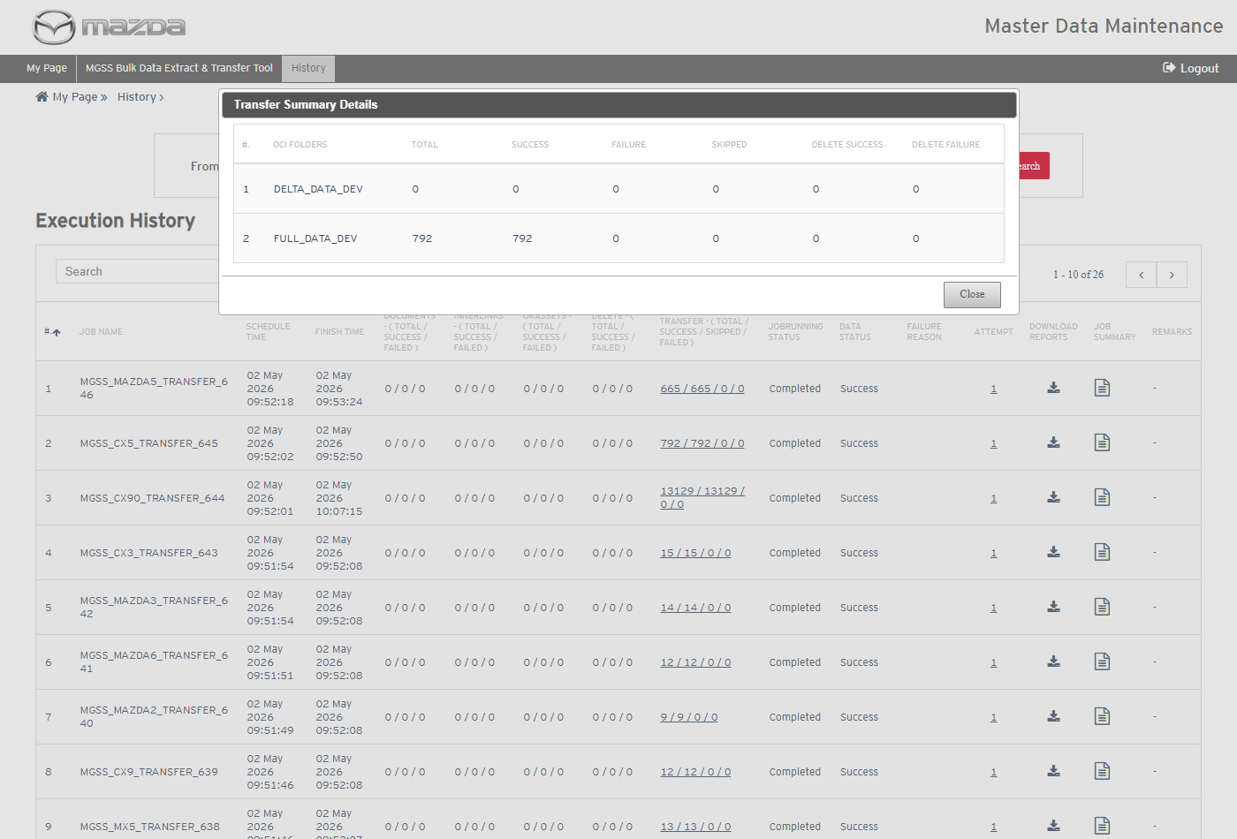
Transfer Summary Details
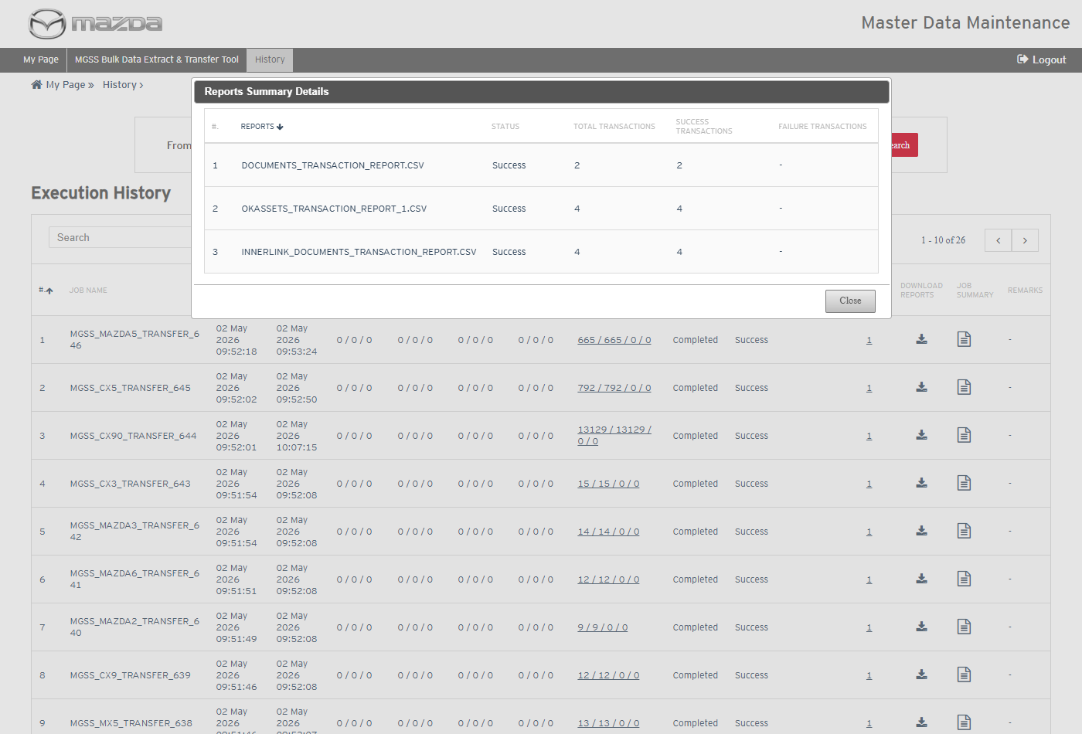
Reports Summary Details
Status: Pass
Remarks:

MGSS Bulk Data - Run On Demand Job
Executed on MC Dev (Linux) for model CX5, locale en-US, on 28-Oct-2026, with the JDK 25 job jars under MGSS_DATA_EXTRACT/jobs. Evidence is taken from the job logs, the generated reports and the History screen.
- Run On Demand job should start the extract for the models requested from the screen.
Pre-condition: Run On Demand was clicked for model CX5 on the MGSS Bulk Data Extract & Transfer Tool screen.
Steps:
1. The Run On Demand job runs (cron, every 5 minutes): jobs/NewMazdaDataRunOnDemandTool/run.sh.
2. Check RunOnDemandMazdaDataExport.log.
Expected Result:
- With no request pending the job logs "No Schedules Found for RunOnDemand. Exiting."
- With the CX5 request pending it finds 1 schedule and starts the extract job with RUNONDEMAND 160 using the JDK 25 of the server (/app/java).
RunOnDemandMazdaDataExport.log
Status: Pass
Remarks:

MGSS Bulk Data - Extract Job
Executed on MC Dev (Linux) for model CX5, locale en-US, on 28-Oct-2026, with the JDK 25 job jars under MGSS_DATA_EXTRACT/jobs. Evidence is taken from the job logs, the generated reports and the History screen. The cases below follow extract job 654 (MGSS_CX5_EXT_654, attempt 1).
- Extract job should create the job and attempt entries and clear the Run On Demand request.
Steps:
1. Extract job runs with RUNONDEMAND 160.
2. Check NawMazdaDataExport.log.
Expected Result:
- Run type RUNONDEMAND; model CX5 is fetched; the request row is deleted from gms3_mdm_nmd_job_rod.
- Job 654 and attempt 1 are created for en-US and the extract thread MGSS_CX5_EXT_..._654_3335 starts.
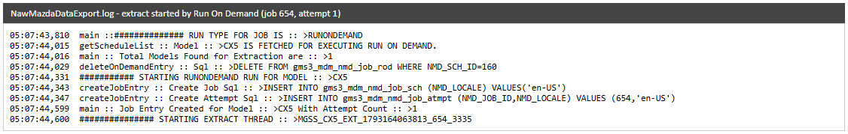
Extract started
Status: Pass
Remarks:

- Extract job should extract the published Kapture documents of the model per channel.
Steps:
1. Check NawMazdaDataExport.log and DOCUMENTS_TRANSACTION_REPORT.CSV.
Expected Result:
- Only documents published in Kapture are selected: SM 0 (no published CX5 documents), WD 29, SI 2.
- Each document is read from the Kapture live content XML (published version) and written to the FULL and DELTA folders.
- The documents report lists the 31 documents with FULL and DELTA processing status Success.
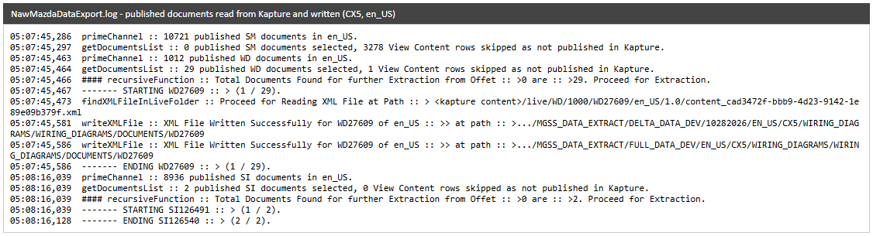
Documents read and written
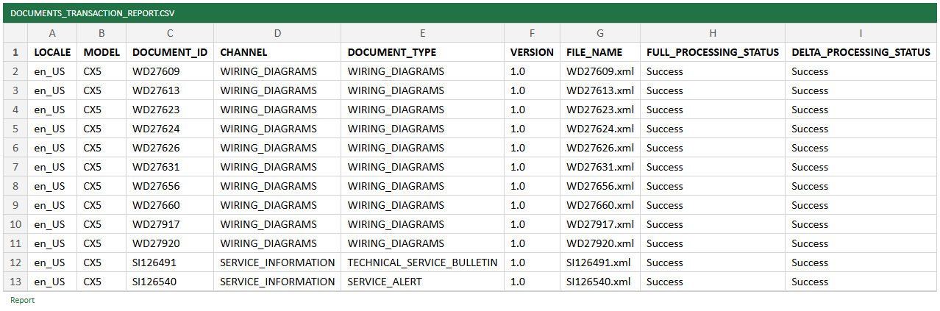
DOCUMENTS_TRANSACTION_REPORT.CSV
Status: Pass
Remarks:

- Extract job should extract the inner link documents and check the documents to delete.
Steps:
1. Check NawMazdaDataExport.log and INNERLINK_DOCUMENTS_TRANSACTION_REPORT.CSV.
Expected Result:
- The Kapture inner link content/SI105715 in SI126491 is detected and SI105715 is extracted as an inner link document (Success).
- Delete documents are checked for SM, WD and SI (Kapture unpublished / expired documents); none found for CX5 in the window.
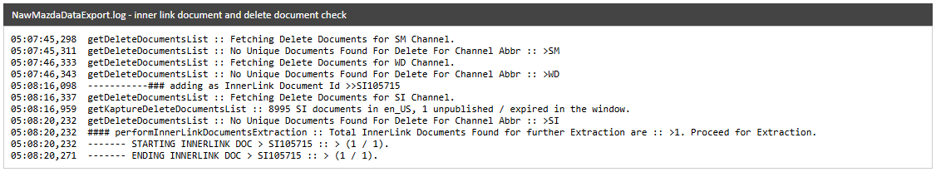
Inner link and delete check
INNERLINK_DOCUMENTS_TRANSACTION_REPORT.CSV
Status: Pass
Remarks:

- Extract job should copy the Wiring Diagram OKAssets and process the voltage map JS files.
Steps:
1. Check NawMazdaDataExport.log and OKASSETS_TRANSACTION_REPORT_1.CSV.
Expected Result:
- The WD material folder is read from en_us/cx-5_km/e-wd/fl0000/e-due-69p1 and its html5 files are copied to OKMASSETS.
- voltagelinkMAP.js and voltageMAP.js are processed and kept whole.
- The OKAssets report lists 3,016 rows (2,987 files; the 29 WD document HTML files are listed both as OKASSETS and DOCUMENT rows), all FULL and DELTA Success.
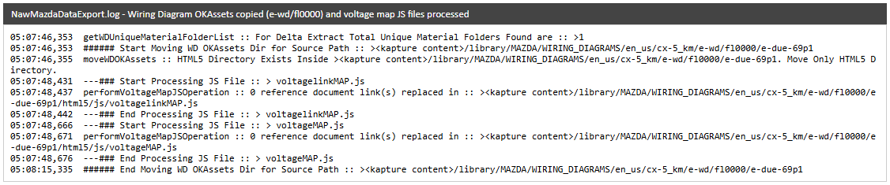
WD OKAssets and JS files
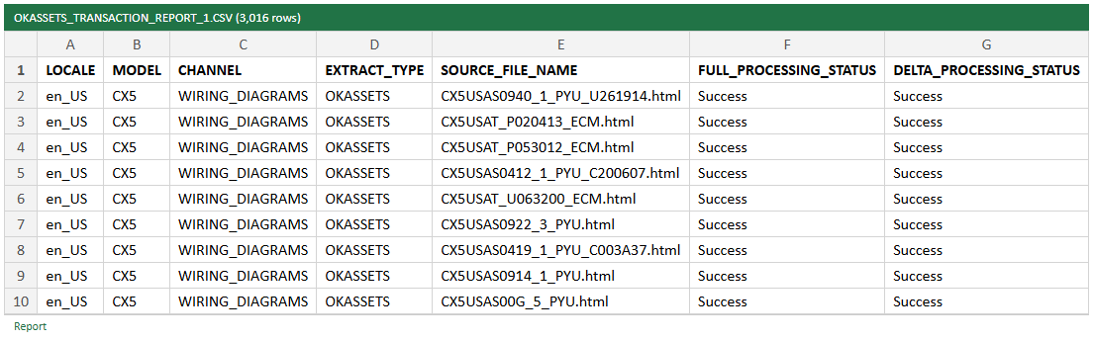
OKASSETS_TRANSACTION_REPORT_1.CSV
Status: Pass
Remarks:

- Extract job should write the META_DATA files of each channel.
Steps:
1. Open the META_DATA folders of the extracted model.
Expected Result: ESIMetaData.csv (ESI categories), ModelYearMetaData.csv (model years) and, for Wiring Diagrams, VinMetaData1.csv (WMI / VDS / VIS ranges) are written for the extracted documents.
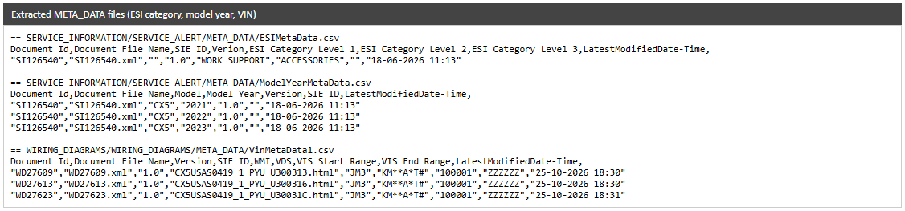
META_DATA files
Status: Pass
Remarks:

- Extract job should create the FULL folder and DELTA zip, set the status and start the transfer.
Steps:
1. Check the MGSS_DATA_EXTRACT folders and the end of NawMazdaDataExport.log.
Expected Result:
- FULL_DATA_DEV/EN_US/CX5 holds the documents and META_DATA per channel and the OKMASSETS files; DELTA_DATA_ZIP/10282026/EN_US/CX5/CX5.zip holds the delta content.
- Job status is set to Success, the mail is sent and the transfer job is started.
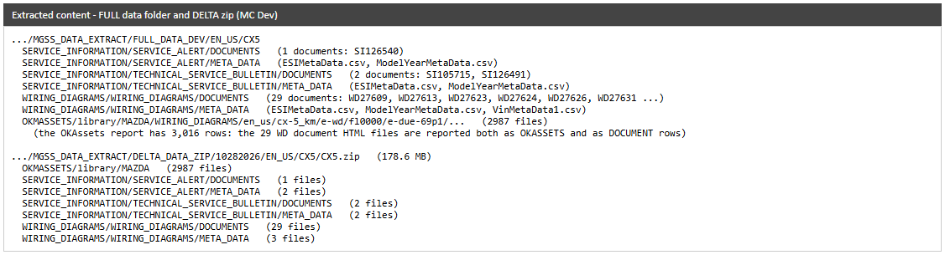
Extracted folders
Extract completed
Status: Pass
Remarks:

- User should be able to see the extract result in History and download its reports.
Steps:
1. Open MGSS Bulk Data Extract & Transfer Tool > History on MC Dev.
2. Click Download Reports of MGSS_CX5_EXT_654.
Expected Result:
- MGSS_CX5_EXT_654 shows Documents 31 / 31 / 0, Inner Links 1 / 1 / 0, OKAssets 3016 / 3016 / 0, Job Running Status Completed and Data Status Success.
- The reports zip holds the documents, inner link and OKAssets transaction reports.
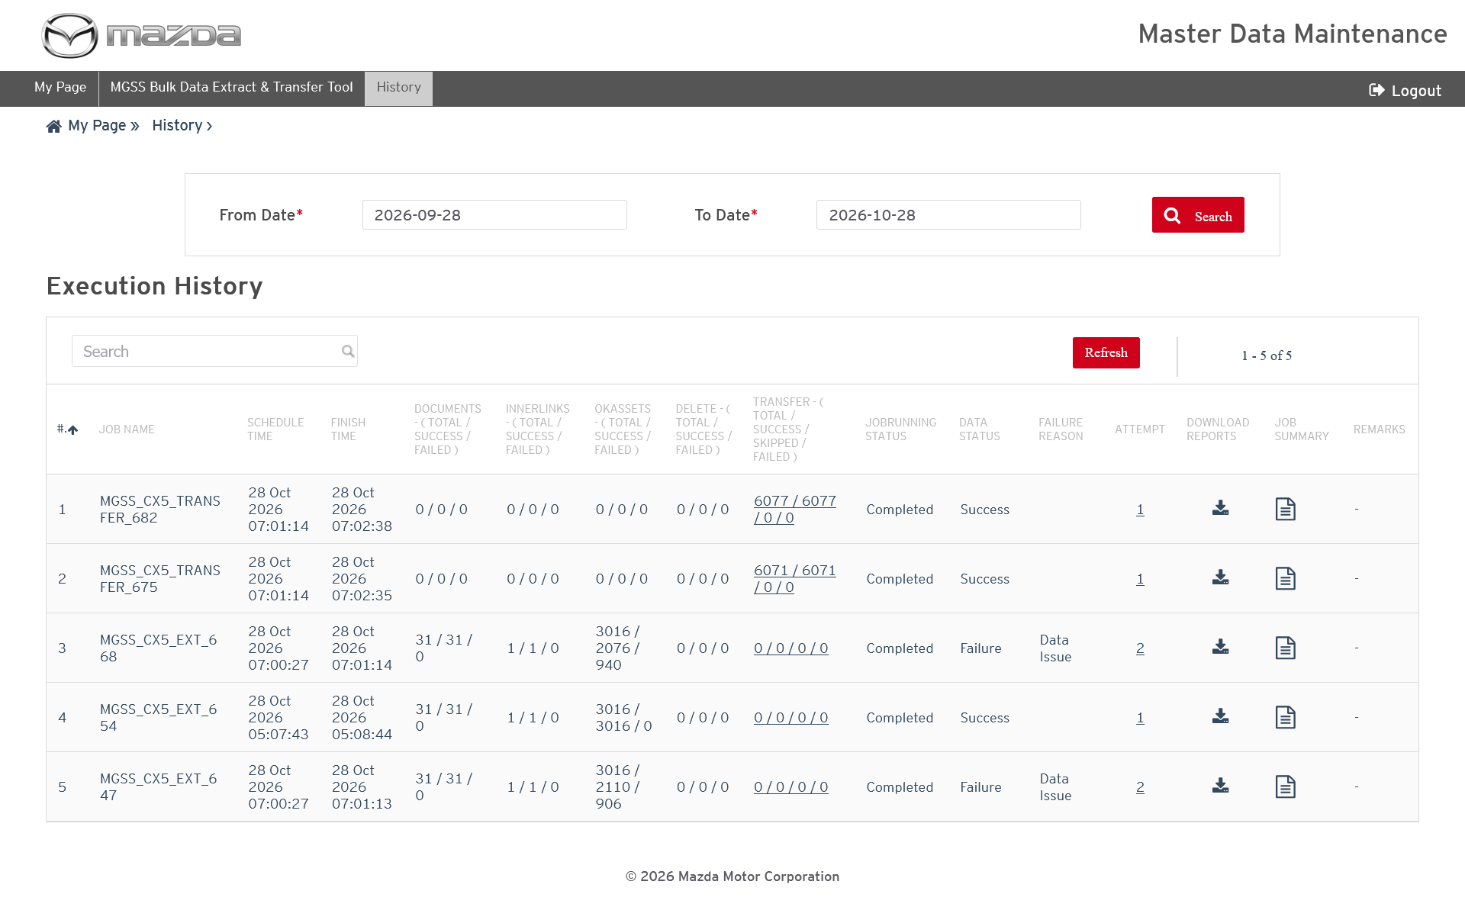
Execution History (MC Dev)
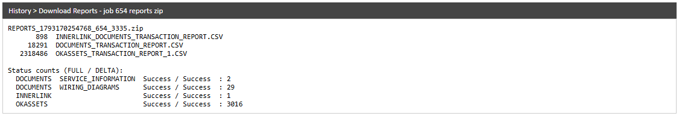
Reports zip
Status: Pass
Remarks:

MGSS Bulk Data - Transfer Job
Executed on MC Dev (Linux) for model CX5, locale en-US, on 28-Oct-2026, with the JDK 25 job jars under MGSS_DATA_EXTRACT/jobs. Evidence is taken from the job logs, the generated reports and the History screen. The transfer job is started by the extract job (not by cron). The cases below follow transfer job 682 (MGSS_CX5_TRANSFER_682); transfer job 675 ran at the same time for another extract of the same model. Because both uploaded the same files at once, one oci sync of each exited with 1 (object already uploaded by the other transfer - IfNoneMatchFailed in the internal report); the files are in the bucket and the transfer report shows Success (existing behaviour).
- Transfer job should upload the extracted content and reports to the OCI bucket.
Steps:
1. Extract completes and starts the transfer job (job id, attempt id).
2. Check NewMazdaTransfer.log.
Expected Result:
- The DELTA zip, the DELTA reports, the FULL folder and the FULL reports are synced to bucket MGSSBULK_DEV with oci os object sync through the MC Dev proxy.
- The transfer report and the internal transfer report are written and the mail is sent.
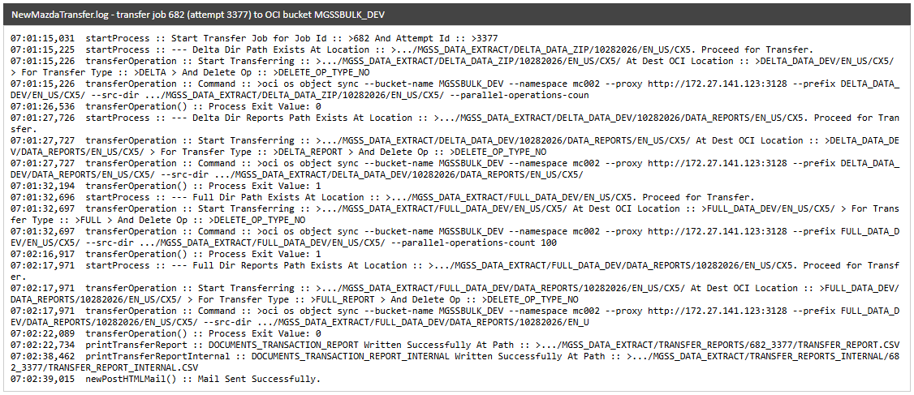
NewMazdaTransfer.log
Status: Pass
Remarks:

- Transferred content and reports should be available in the OCI bucket.
Steps:
1. Open OCI Console > Object Storage > Buckets > MGSSBULK_DEV > Objects.
2. Browse the DELTA_DATA_DEV and FULL_DATA_DEV prefixes of EN_US / CX5.
Expected Result:
- DELTA_DATA_DEV/EN_US/CX5/ holds CX5.zip (178.62 MiB, last modified Oct 28, 2026 07:01 UTC).
- DELTA_DATA_DEV/DATA_REPORTS/EN_US/CX5/ATTEMPT_1/ and ATTEMPT_2/ hold the documents, inner link and OKAssets transaction reports of the run (07:01 UTC). The REF_DOCUMENTS report dated Apr 1, 2026 in ATTEMPT_1 is from an earlier load and is kept, as the sync does not delete.
- FULL_DATA_DEV/DATA_REPORTS/10282026/EN_US/CX5/ATTEMPT_1/ and ATTEMPT_2/ hold the same three reports (07:02 UTC).
- FULL_DATA_DEV/EN_US/CX5/ holds the OKMASSETS, SERVICE_INFORMATION and WIRING_DIAGRAMS folders (SERVICE_MANUALS is from earlier loads; this run had no published CX5 SM documents), and the Wiring Diagram html5 files are under OKMASSETS/library/MAZDA/WIRING_DIAGRAMS/en_us/cx-5_km/e-wd/fl0000/e-due-69p1/html5/ (07:01 UTC).
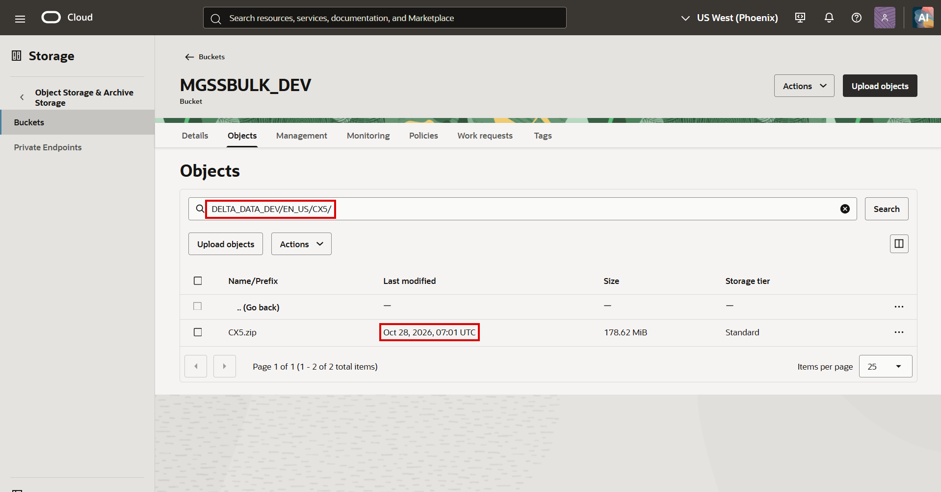
DELTA_DATA_DEV/EN_US/CX5/
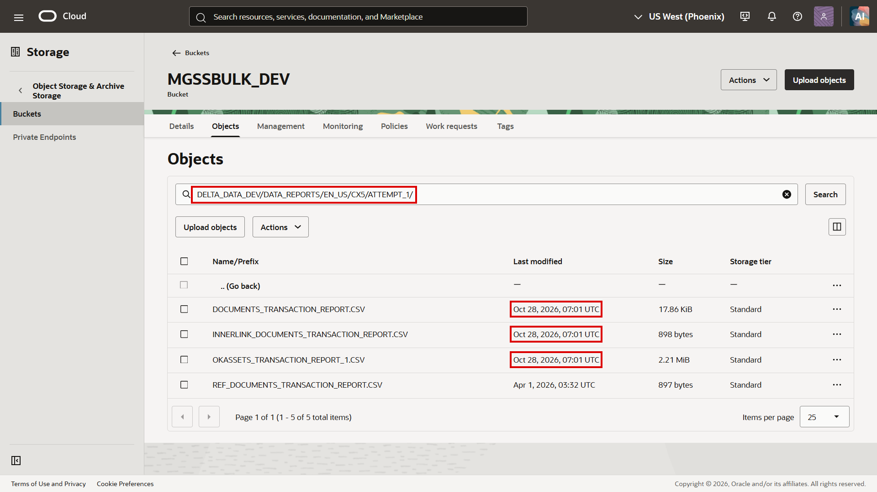
DELTA_DATA_DEV/DATA_REPORTS/EN_US/CX5/ATTEMPT_1/
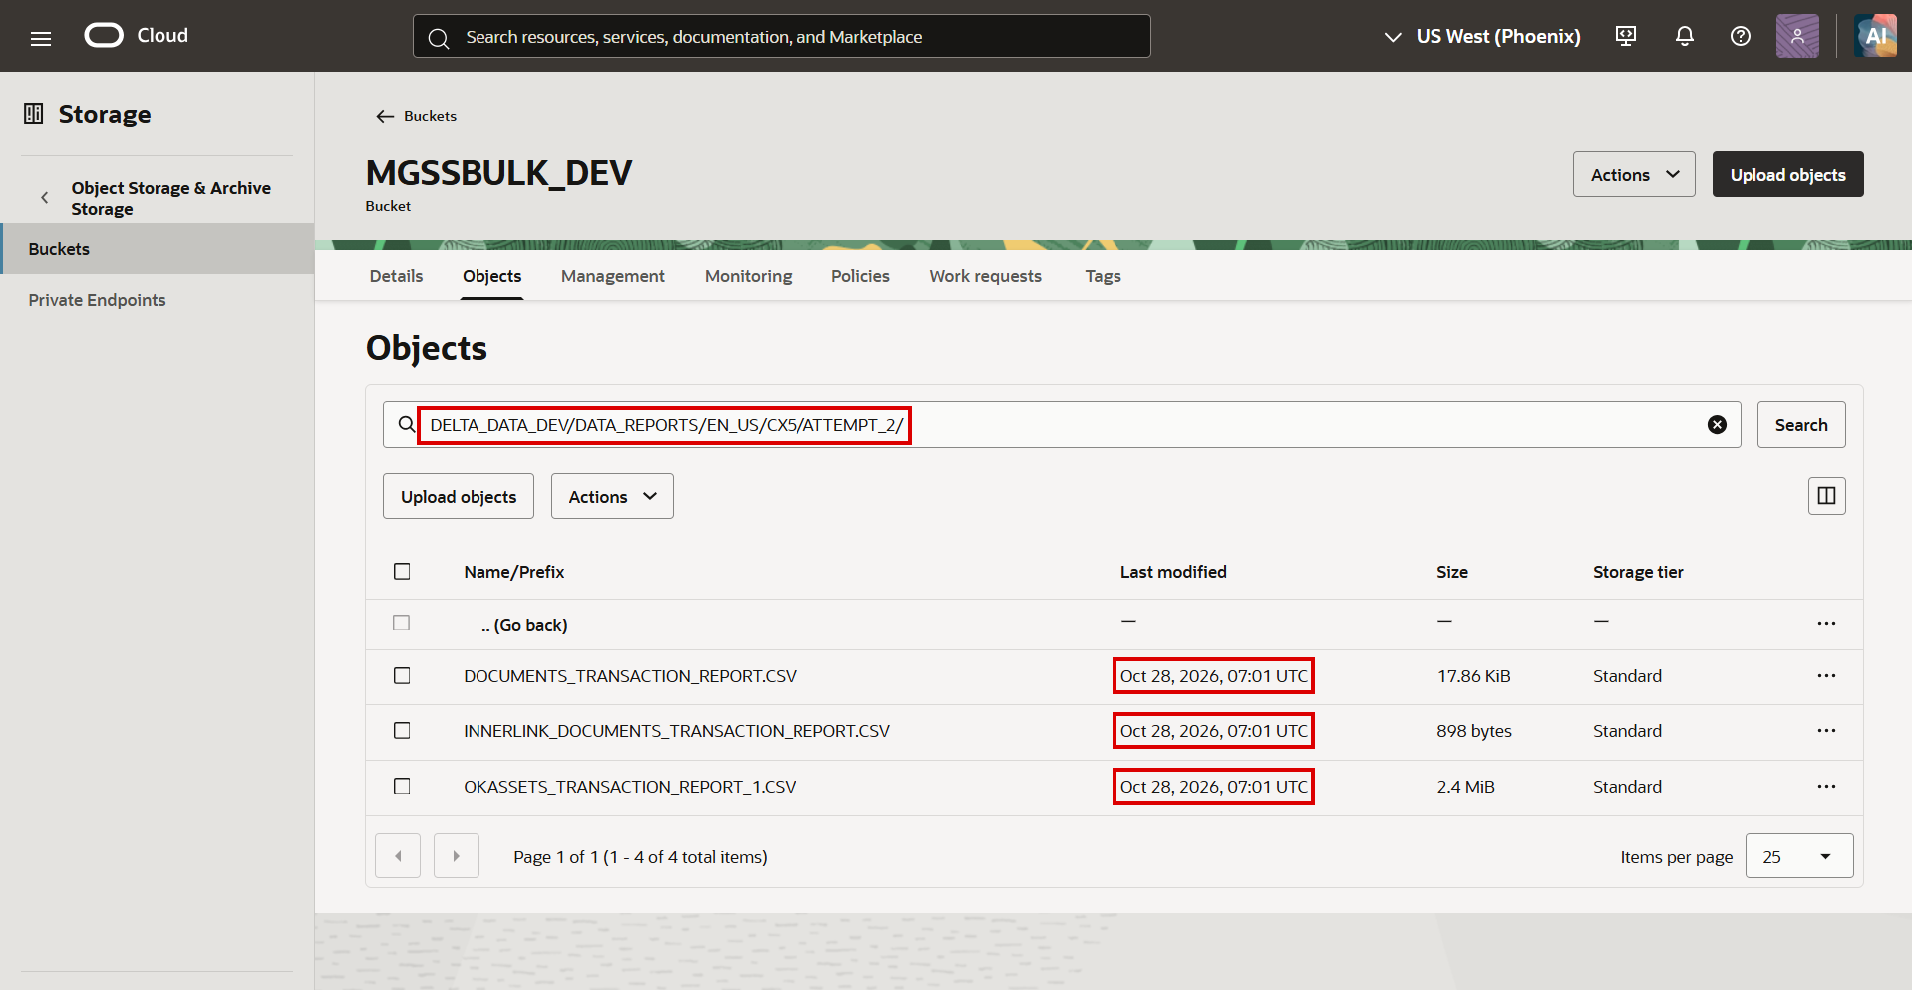
DELTA_DATA_DEV/DATA_REPORTS/EN_US/CX5/ATTEMPT_2/
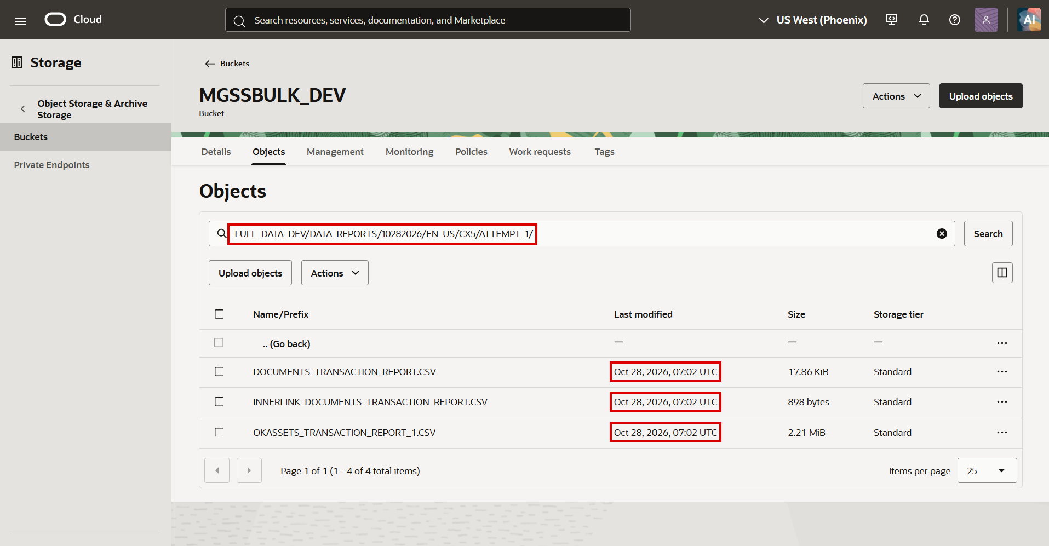
FULL_DATA_DEV/DATA_REPORTS/10282026/EN_US/CX5/ATTEMPT_1/
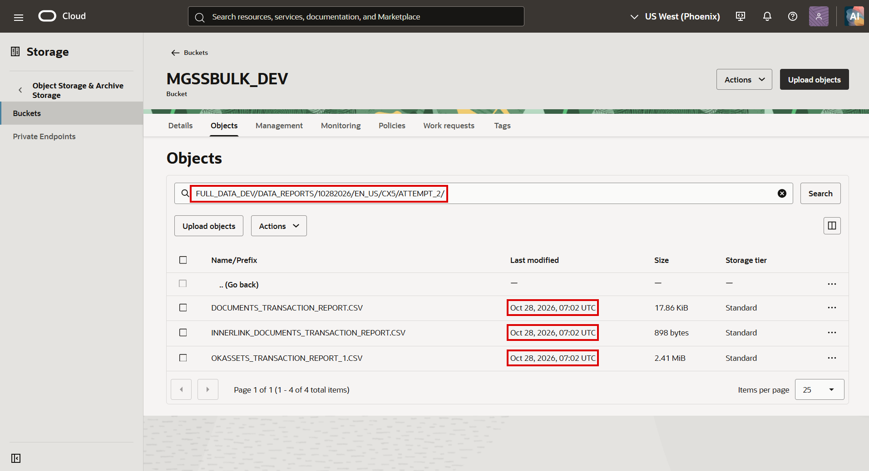
FULL_DATA_DEV/DATA_REPORTS/10282026/EN_US/CX5/ATTEMPT_2/
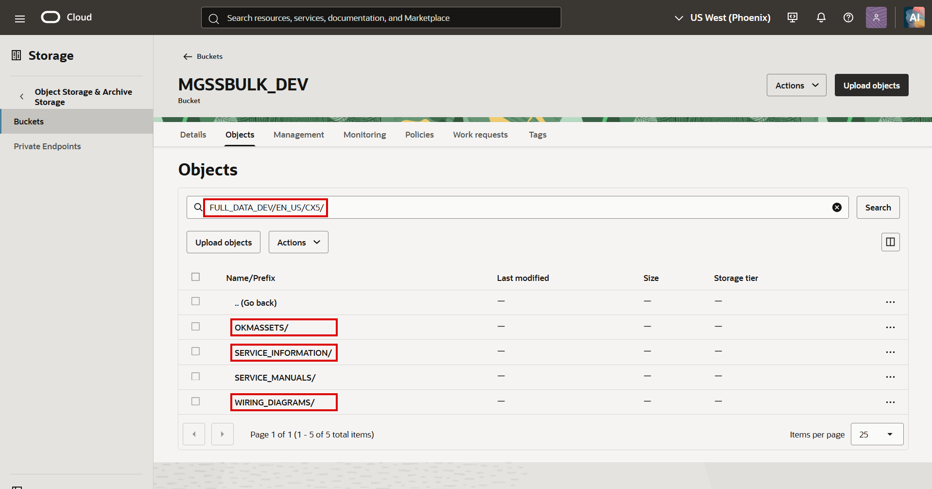
FULL_DATA_DEV/EN_US/CX5/
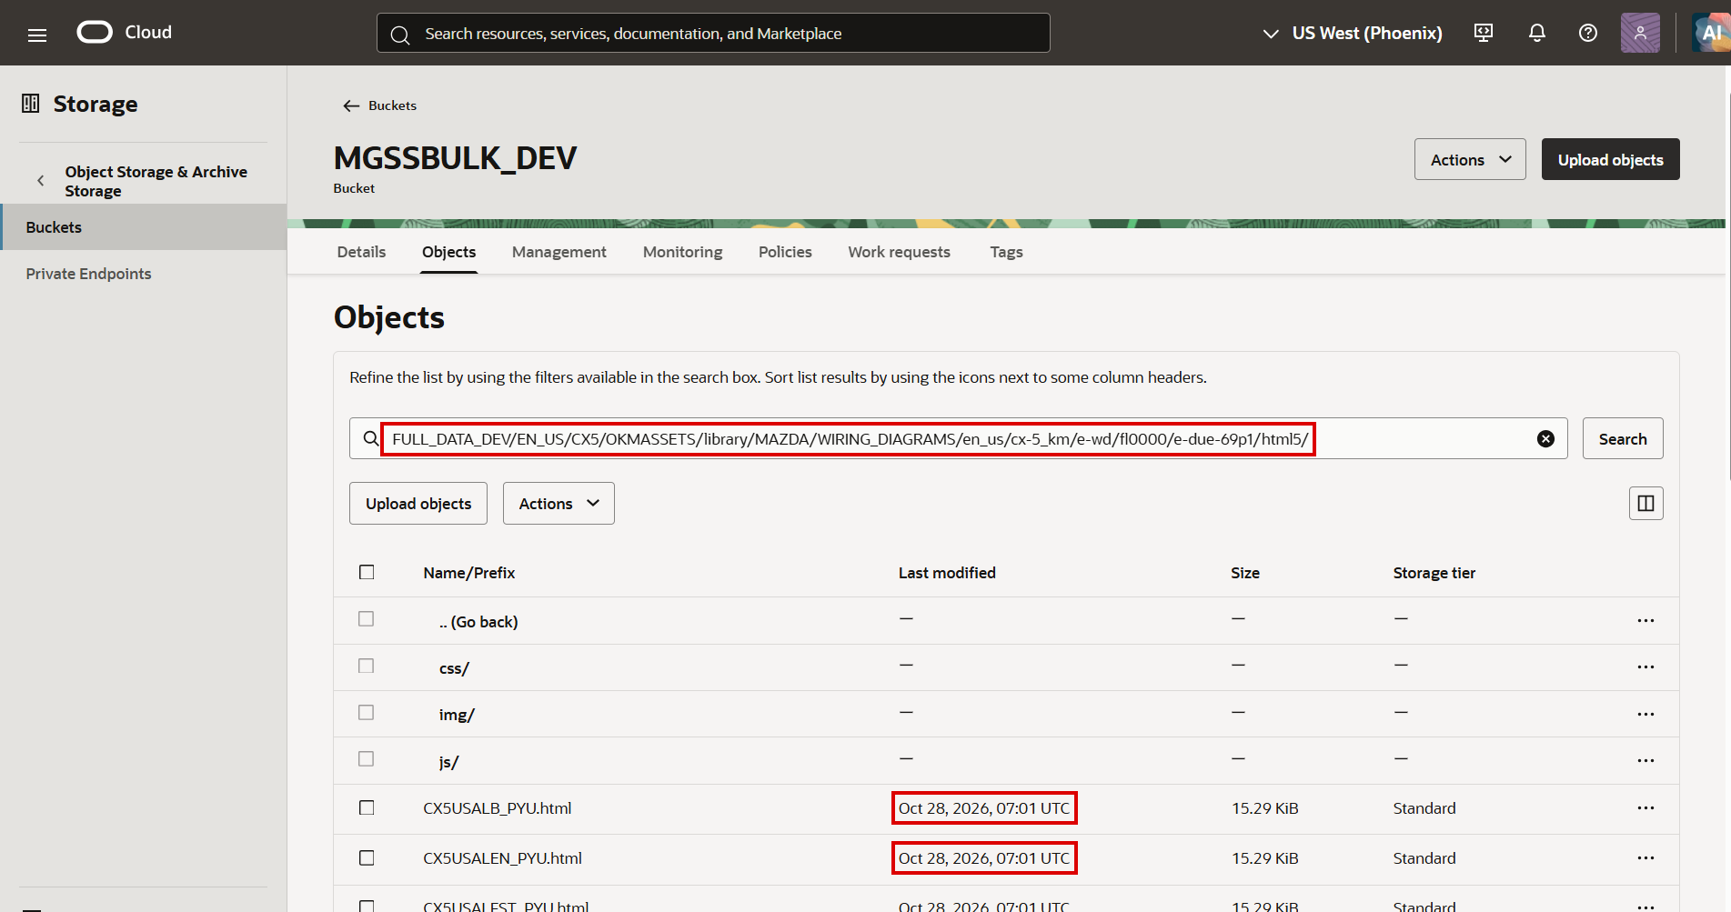
FULL_DATA_DEV/EN_US/CX5/OKMASSETS/.../html5/
Status: Pass
Remarks:

- User should be able to see the transfer result in History and the transfer report.
Steps:
1. Open History on MC Dev.
2. Open TRANSFER_REPORTS/682_3377/TRANSFER_REPORT.CSV.
Expected Result:
- MGSS_CX5_TRANSFER_682 shows Transfer 6077 / 6077 / 0 / 0 and MGSS_CX5_TRANSFER_675 shows 6071 / 6071 / 0 / 0, both Completed / Success.
- The transfer report lists every uploaded DELTA and FULL file with status Success.
Execution History (MC Dev)
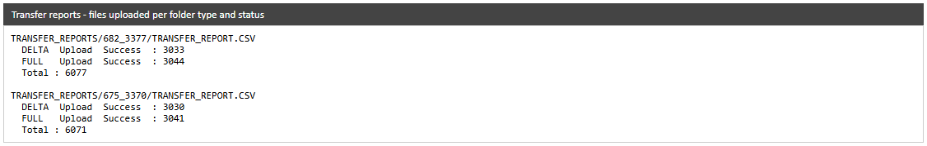
Uploaded files
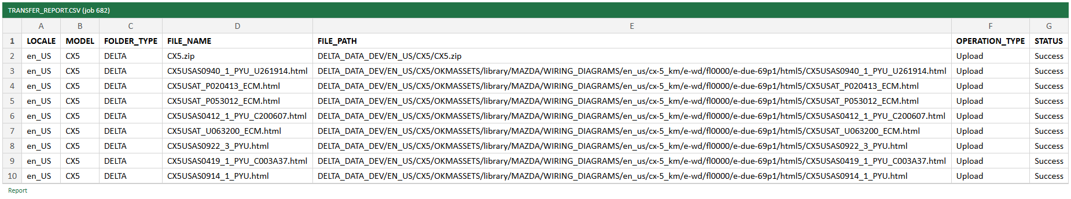
TRANSFER_REPORT.CSV
Status: Pass
Remarks:

MGSS Bulk Data - Rerun
Executed on MC Dev (Linux) for model CX5, locale en-US, on 28-Oct-2026, with the JDK 25 job jars under MGSS_DATA_EXTRACT/jobs. Evidence is taken from the job logs, the generated reports and the History screen. RERUN is the extract job started with the RERUN argument (cron, every 5 minutes). The two restarted jobs were for the same model and ran at the same time on the same folders, so each found files already copied by the other and both ended with Data Status Failure / Data Issue; this case covers the restart itself.
- RERUN should restart the aborted extract jobs with a new attempt.
Pre-condition: Extract jobs 647 and 668 (CX5) were Aborted (System Issue) in attempt 1.
Steps:
1. Run jobs/NewMazdaDataExportTool/run.sh RERUN.
2. Check NawMazdaDataExport.log and History.
Expected Result:
- Jobs 647 and 668 are found Aborted and restarted as attempt 2 (new attempt rows, new extract threads).
- The transfer job still running (661) is reported as STILL RUNNING and not restarted.
- History shows MGSS_CX5_EXT_647 and MGSS_CX5_EXT_668 with Attempt 2, and their transfers 675 and 682.
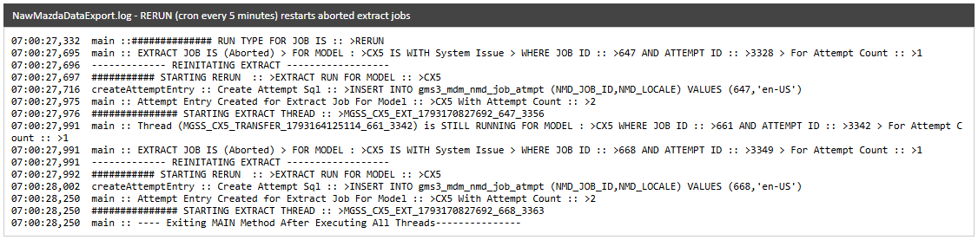
RERUN log
Execution History (MC Dev)
Status: Pass
Remarks:

